Annual WHISE Stakeholder Engagement and Impact Survey: 2023

Acknowledgement of Country
Women’s Health in the South East acknowledges the traditional owners of the land of the Southern Metropolitan Region of Melbourne including the Bunurong People and Wurundjeri People of the Kulin Nation. We pay our respects to Elders past, present and emerging. WHISE acknowledges that sovereignty of this land has never been ceded and we are committed to honouring Australian Aboriginal and Torres Strait Islander peoples in our work.

Contents
Acknowledgement of Country 2
Who are we? 4
Primary prevention 4
Where we work 4
Acronyms 5
Background 6
Methods 6
Survey results 7
About the respondents 7
Local Government Areas 7
Type of organisation 8
Professional roles 10
Involvement with WHISE 12
WHISE membership 12
Involvement with WHISE activities and/or work 13
Motivation to work with WHISE 17
Perceptions and ratings of WHISE 20
Recommend WHISE to a friend or colleague 20
Quality of service 22
Words associated with WHISE 23
Issues and agendas addressed by WHISE 25
Areas for work and advocacy 28
Comparisons with 2021 responses 28
Suggested priorities for the next 12 to 18 months 29
Comparisons with 2021 responses 30
Areas of capacity or capability building WHISE should provide services for 31
Comparisons with 2020 responses 32
Concluding remarks 33
References 35

Who are we?
Women’s Health in the South East (WHISE) is the regional women’s health service for the Southern Metropolitan Region. WHISE is a not-for-profit organisation that focuses on empowering women.
We work to improve the health and wellbeing of women in our region by providing health information and education to governments, organisations, education providers, and community groups.
Our team of health promotion professionals work to promote gender equality, sexual and reproductive health and the prevention of violence against women.

Primary prevention
Primary prevention in health promotion is at the very core of what we do. It is a deliberate way of changing the underlying causes of poor health. Rather than treating disease, our work seeks to prevent disease. WHISE work aims to reduce incidence of poor health of women in our community.
We train and raise understanding about gender equality because we know that this is the root cause of violence against women. We work in partnership with communities on sexual and reproductive health to support women to take control over their own health and wellbeing.
Health Promotion and Primary Prevention increases community wellbeing and most importantly for us, empowers women.

Where we work
We work across 10 local government areas. Our area of work is called the South Metropolitan Region and consists of approximately 1.3 million people, representing about one-quarter of the state’s total population.
We cover Port Phillip, Bayside, Kingston, Frankston, Stonnington, Glen Eira, Dandenong, Cardinia, Casey and Mornington Peninsula.

Acronyms
CALD | Culturally and linguistically diverse
CoP | Community of Practice
GHDS | Good Health Down South
LGA | Local government area
PRET | Promoting Respect & Equity Together
GE | Gender equality
NPS | Net Promotor Score
PVT | Preventing Violence Together
PVAW | Prevention of violence against women
SC | Steering Committee
SMR | Southern Metropolitan Region
SRH | Sexual and reproductive health
WHISE | Women’s Health in the South East

Background
WHISE values working in partnership with businesses and individuals in the Southern Metropolitan Region (SMR). These relationships are important as they add to our knowledge of the SMR and inform and strengthen the success of our work. WHISE is informed by these partnerships through Community of Practice (CoP) meetings, Steering Committee (SC) meetings, working group meetings, consultations and more.
In 2019, WHISE made the decision to collect views and feedback more purposefully from our partners. We also wanted to know more about the people and businesses who were connected to WHISE. Thus, the first annual Stakeholder Engagement and Impact Survey was undertaken to enable us to better understand the needs of our partners, members and stakeholders, and to help us to better support all women, young girls and gender diverse people in our region. This survey was distributed again in 2020, 2021, and 2022.
With a two-year boost of funding for the Victorian Women's Health Services announced in the 2022/23 State Budget, the government has shown a commitment to eliminating gender inequities and improving outcomes in women’s health, safety and wellbeing through primary prevention and health promotion. Thus, measuring our reach and impact is now more important than ever.
The responses to this year’s survey are therefore important as they will help to inform the areas/issues and priority areas that WHISE will work/advocate on over the next 12 to 18 months.
This report will provide a summary and discussion of the results from the Stakeholder Engagement and Impact Survey 20223.

Methods
The 2023 annual Stakeholder Engagement and Impact Survey included the same questions as the previous iterations of the survey. Some of the questions, however, included additional response options to reflect WHISE’s evolving work. For example, the question asking, “Which of the following issues and agendas do you know WHISE has presented on and/or produced position papers on?” included several new additions that reflected the work we produced in 2023. The same questions are presented each year to enable comparisons that reveal changing trends.
The survey was open from August 14th, 2023, to December 2nd, 2023. WHISE promoted the survey through social media posts, a banner in WHISE’s employee’s email signatures, and through their Electronic Direct Mail (EDM) list.
The survey was completed by 41 people. This was a 24% decrease from 2022 when 54 people completed the survey, and a 55% decrease from 2021 when 91 people completed the survey. This may be because the survey was delivered a bit later in the year during a busier time for our partners and stakeholders. Of the 41 respondents, on average 68% (n=28) completed all quantitative questions. On average 29% (n=12) completed all qualitative short-answer questions. The most skipped question was, “Are there any specific areas of capacity or capability building (including training) that you think WHISE should be providing services for?” (skipped=29). This may be attributed to the placement of this question at the end of the survey, as it became evident that participants were more likely to disengage as they approached the survey's conclusion. Overall, this survey had a 69% completion rate.

Survey results

About the respondents

Local Government Areas
Figure 1 shows the local government areas (LGAs) that people were working in. As can be seen, respondents mostly worked in the following LGAs:
- Victoria wide
- Greater Dandenong and Casey: both 17%
- Mornington Peninsula: 15%
Few respondents worked in:
- Cardina: 10%
- Stonnington: 7%
- Port Phillip: 5%
People who selected “other” (5%) said that they worked in:
- I don’t work
- Melbourne
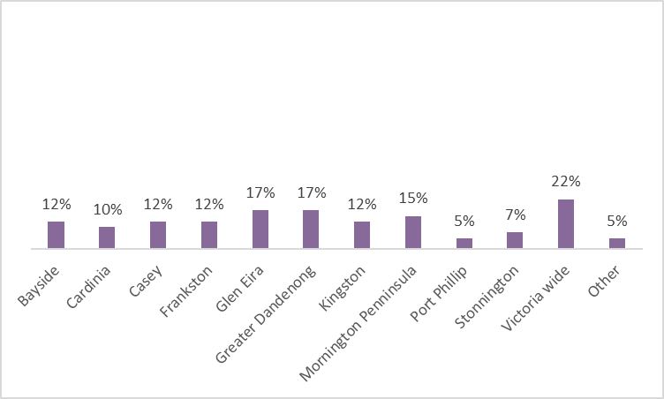
Figure 1. Local government areas that respondents worked in 2023.

Compared with the 2022 survey, Figure 2 shows that 2023 saw increases in the proportions of respondents from the following LGAs:

- Victoria wide
- Glen Eira

Meanwhile, the proportions of respondents from the following LGAs showed decreases from 2022 to 2023:

- Bayside
- Casey
- Cardina
- Frankston
- Mornington Peninsula
- Port Phillip
- Greater Dandenong
- Kingston

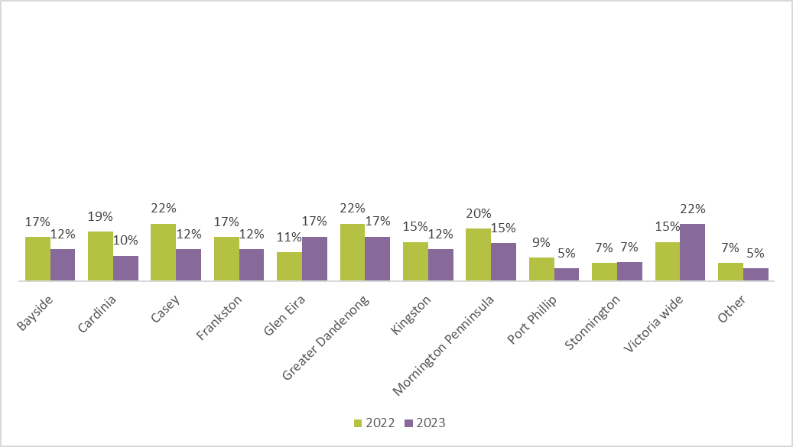
Figure 2. Local government areas that respondents worked in 2022 and 2023.
It was identified that despite a decrease in the propositions of respondents from Greater Dandenong, it was recognised these regions have the highest propositions of respondents in both 2022 and 2023. Similarly, Kingston had a high proportion of responses compared to other LGAs. It was also identified that the number of respondents in Stonnington remained that same in both 2022 and 2023.

Type of organisation
In 2023, the respondents worked in a variety of different organisations. As can be seen in Figure 3, the majority of respondents worked in:
- A large not for profit organisation (defined as having a turnover above $1 million): 22%
- Local government: 20%
- Community health organisations: 17%
- Public Health organisation: 15%
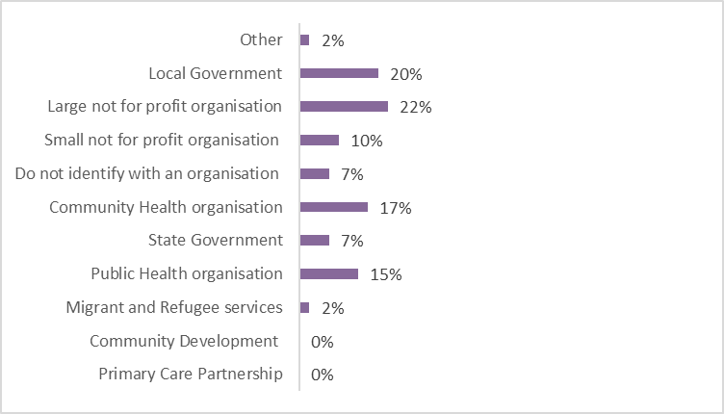
Figure 3. Type of organisation that respondents worked in 2023. Small not for profit = turnover under $1 million. Large not for profit = turnover above $1 million.
Figure 4 shows that there were increases from 2021 to 2022 in the proportion of respondents who worked in:

- A large not for profit organisation (defined as having a turnover above $1 million)
- Community Health organisation
- Public health organisation

However, there were decrease respondents working in the following organisations:

- Local government
- Small not for profit organisations

- Those who do not identify with an organisation
- Migrant and Refugee services

One person responded with ‘other’:
- Family violence partnership
It was also identified that the number of respondents in state government remained that same in both 2022 and 2023.

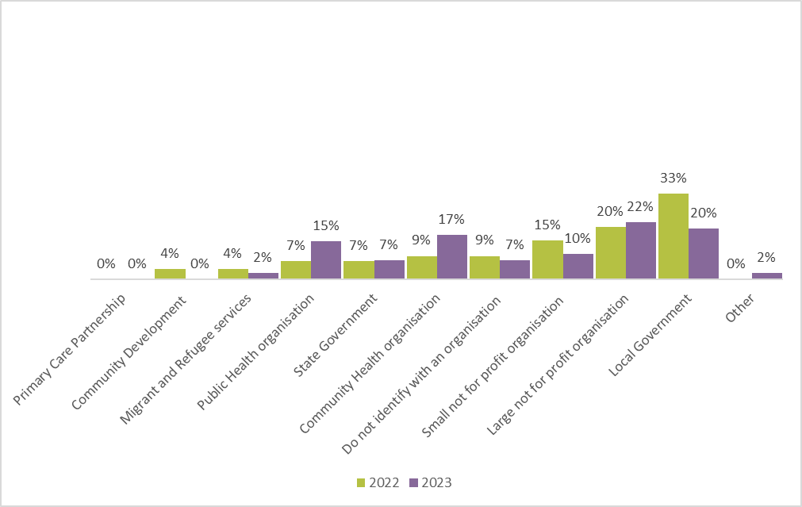
Figure 4. Type of organisation that respondents worked in 2022 and 2023. Small not for profit = turnover under $1 million. Large not for profit = turnover above $1 million.

Professional roles
Figure 5 shows that in 2023, the respondents were working in a diverse range of professional roles. Most of respondents entered a profession that was not listed (25%), however the most popular profession being Manager of staff (30%). The remaining respondents were evenly spread across a variety of professional roles.
The respondents who entered a professional that was not listed are included below:

- Playgroup Development Officer
- Counsellor
- Sector Co-ordination Role (PSA)
- Specialist Family Violence Advisor
- Volunteer in many fields
- Support worker
- Business and Finance
- Admin Support
- Principal Strategic Advisor - Family Violence
- Settlement Worker

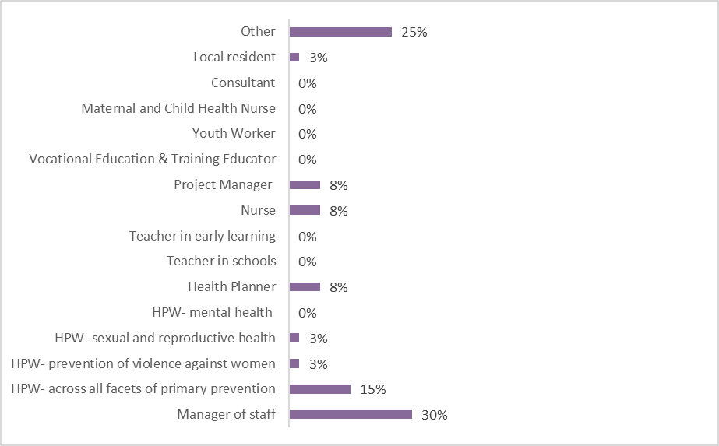
Figure 5 .The professional role of respondents in 2023. HPW = Health Promotion Worker. *Administration includes Administration with Primary Health Services.
Comparisons of the responses from 2022 to 2023 shows the increased diversity of WHISE’s partnerships and hence the increased diversity in our work. Indeed, as can be seen in Figure 6, there were respondents in several roles that were not present in the 2022 survey which demonstrates WHISE’s wide reach in the community:

- Volunteer
- HR Head
- Policy officer
- Social worker
- Positive Aging Officer
- Grants Officer
- Gender Impact Advisor
- Playground Development Officer
- Social Worker
- Advocate
- Strategic Lead Gender Equality
- Community Development
- Disability ageing well, homelessness response and financial wellbeing
- Care and Recovery Clinician
- Early Childhood educator
- Student
- Committee member

Figure 6 also demonstrates from 2022 to 2023, there were increased proportions of respondents in the following roles:

- Manager of staff
- Health promotion worker - across all facets of primary prevention
- Health promotion worker – Prevention of violence against women
- Health planner
- Nurse
- Project manager
However, there were decreased respondents working in the following organisations:
- Health promotion worker – Sexual and reproductive health
- Manger of staff
- Youth worker
- Local resident
- Consultant
There were no respondents working as a teacher in schools, a health promotion worker- mental health, a teacher in early learning, a vocational educational and training educator, or a Material child nurse in 2022 and 2023.
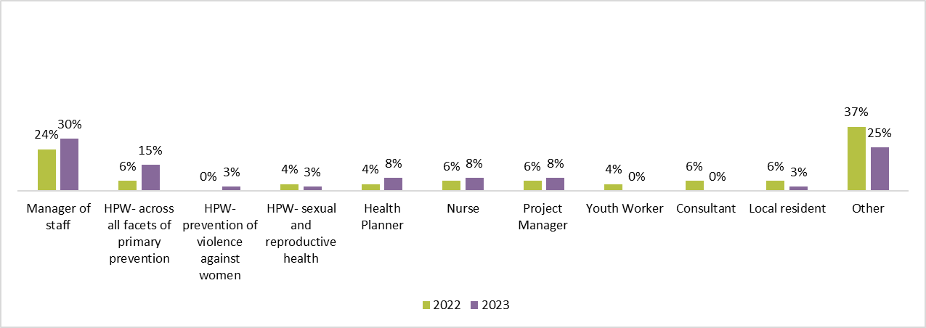
Figure 6. The professional role of respondents in 2022 and 2023. HPW = Health Promotion Worker.

Involvement with WHISE
The annual survey asks respondents about involvement with WHISE. This helps us to understand which activities and/or work stakeholders are connecting with us through and to get a sense of their understanding of/familiarity with our work.

WHISE membership
Respondents were first asked whether they were a member of WHISE. Members of WHISE receive newsletters, updates, and invitations to events such as the Annual General Meeting. Seventy-four people answered this question. As can be seen in Figure 7, a higher proportion of respondents in 2023 (41%) were WHISE members than in 2022 (37%).
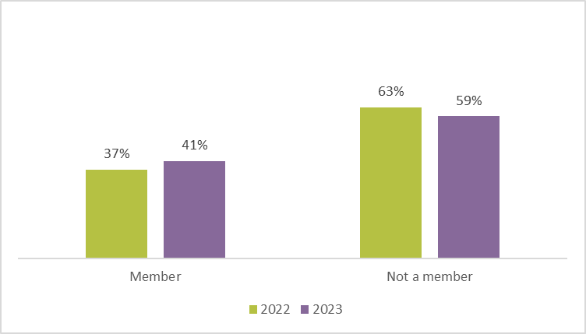
Figure 7. Proportion of respondents who were WHISE members in 2022 and 2023.

It is worth noting that in 2022, while only 41% of respondents were members of WHISE, 84% had some level of involvement with WHISE's work and activities (see Figure 8). This demonstrates that many respondents can provide inciteful feedback on the services provided by WHISE due to a level of familiarity. It also demonstrates stakeholders are engaged in our work regardless of membership.
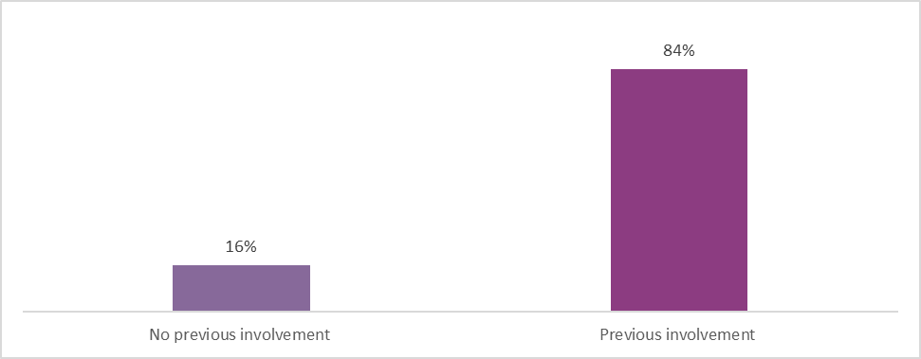
Figure 8 Previous involvement with WHISE respondents in 2023.

Involvement with WHISE activities and/or work
The survey asked which areas of WHISE’s work and activities respondents were currently involved in. A list of 13 activities were included in the survey and respondents were able to select more than one option. Responses from 2022 (n = 72) and 2023 (n = 31) are displayed in Figure 9.
Figure 9 shows that in 2023, the respondents were involved in a diverse range of areas and activities. Most of respondents entered an area of work that was not listed (35%). The remaining respondents were evenly spread across a variety of areas of work and activities.
The respondents who entered an activity or an area of work that was not listed are included below:
- Feminist Friendships program
- I have worked with WHISE on organising some capacity building activities for PRET.
- Supporting implementation of Gender Equality Act requirements for public entities
- Menopause Working Party
- Good Health Down South
- Menopause Working Group
- interviewing WHISE on 88.3 Southern FM community block
- I attended a seminar with WHISE a couple of years ago at the Sandringham Football club.
- I am a victim of domestic violence. I have been ignored by the department officials.
- Collaboration on sexual and reproductive health programs/activities
- I have delivered training to staff of WHISE

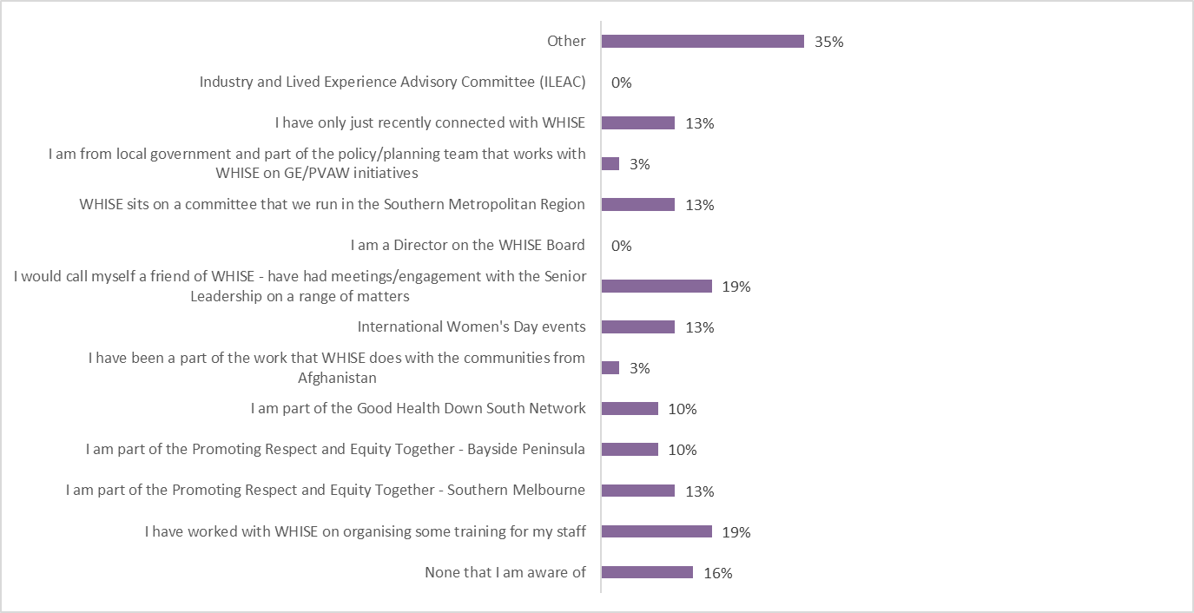
Figure 9 Areas of WHISE’s work and activities respondents were currently involved in respondents in 2022.

Comparisons of the responses from 2022 to 2023 shows the increased diversity of WHISE’s partnerships and hence the increased diversity in our work. Indeed, as can be seen in Figure 10, there were respondents in several roles that were not present in the 2022 survey which demonstrates WHISE’s wide reach in the community:
- I am a previous volunteer but enjoy emails and up to date information about the community and look forward to possibly working again with WHISE.
- Worked with WHISE on organising training for WHISE/PRET staff.
- Foundation member.
- Respecting Seniors network.
- Workplace Gender Audit as a State Government Entity and development of our GEAP.
- Previously on the WHISE committee.
- Follow WHISE social media.
- Recently retired from Women’s Services PH.
- WHISE staff supported my work.
- Attending training organised by WHISE.
As can be seen, in 2023, the biggest increases in involvement in participation can be observed for:
- I am part of the Good Health Down South network
- I am from local government and part of the policy/planning team that works with WHISE on GE/PVAW initiatives
- None that I am aware of
There were, however, decreases in involvement in the following activities and work:
- I am part of the PVT Strategy - Community of Practice
- I worked with WHISE and supported the Settlement Services Program
- I am a Director on the WHISE Board
- I am part of the GHDS - Steering Committee
- I have worked with WHISE on organising some training for my staff
- I am part of the Promoting Respect and Equity Together - Southern Melbourne
- I am part of the Promoting Respect and Equity Together - Bayside Peninsula
- I have been a part of the work that WHISE does with the communities from Afghanistan
- International Women's Day events
- I would call myself a friend of WHISE - have had meetings/engagement with the Senior Leadership on a range of matters
- I am a Director on the WHISE Board
- WHISE sits on a committee that we run in the Southern Metropolitan Region
- I have only just recently connected with WHISE
- Other
Industry and Lived Experience Advisory Committee (ILEAC) was the only activity and area of work that did not have any responses in 2022 and 2023.
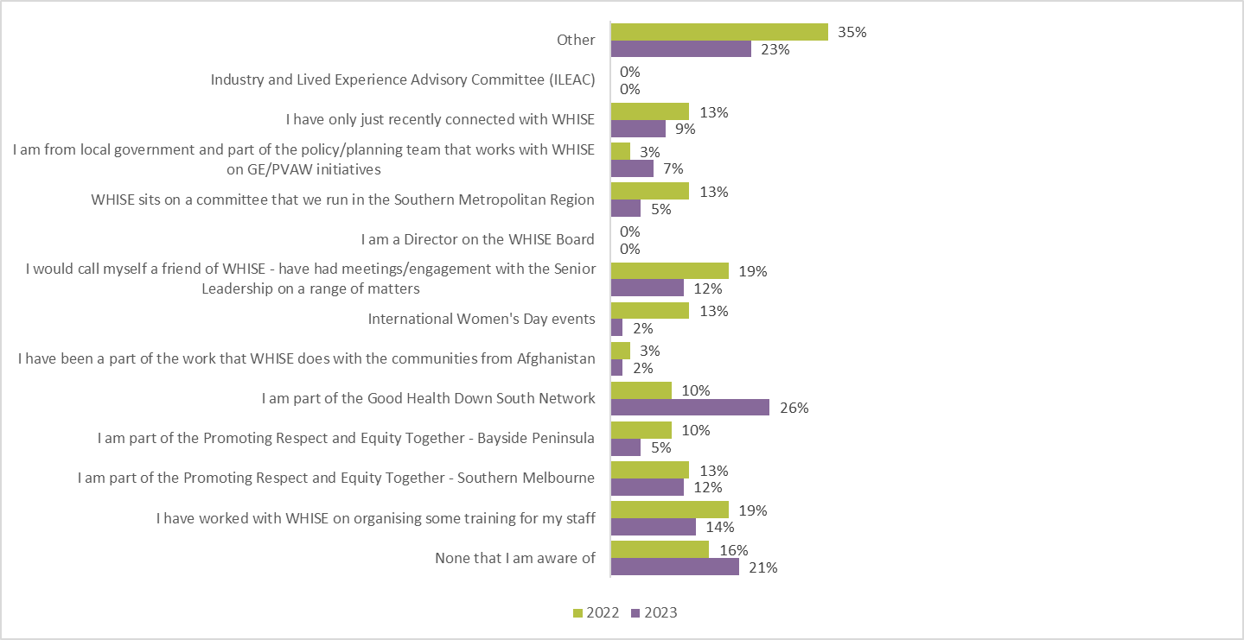
Figure 10. Areas of WHISE’s work and activities respondents were currently involved in respondents in 2022 and 2023.

Motivation to work with WHISE
Respondents were asked about their motivation to work with WHISE. Ten options were presented along with an “other” response option. Figure 11 displays the proportions of respondents in 2022 (n = 43) and 2023 (n = 32) who answered this question.
As can be seen, the most frequently selected motivations in 2023 were:
- I believe in the goals and what WHISE stands for: 66%
- I have an interest in the area: 50%
- I like working with WHISE: 38%
In 2023, the least frequently selected motivations were:
- I need a supplier of services: 6%
- I was asked to sit on one of the committees by my employer: 6%
- As a funder with Government WHISE is part of a program that I/my team manage: 3%
- Not really sure: 3%
In 2023, respondents (28%) listed the following additional motivating factors for working with WHISE:
- Attracted the skills/competencies of the WHISE team.
- Self-education of local projects and services in my area.
- I attended a recent forum and was inspired by WHISE.
- Connected with other professionals across the region.
- 16 days of activism- they cover areas that are different but relevant to our service users.
- Interested to learn about improving conditions for women.
- I want to help jab injured and people who have been cast out of medical systems.
- I would like to help migrant women who is facing domestic violence, domestic abuse who come from strong cultural breakdown. Since I was not identified as a victim due to negligence of departments and health department, I want to help women who are struggling and undergoing the same situation I have undergone in my life.
- WHISE staff are truly creative and big thinkers.

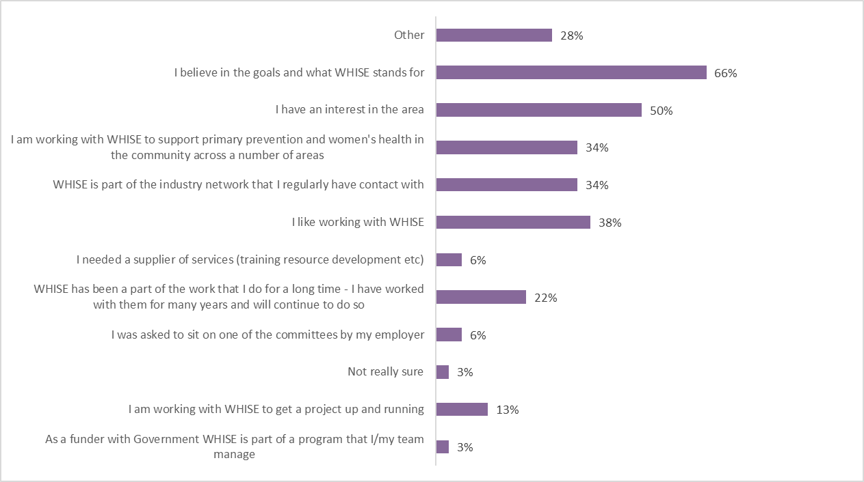
Figure 11. Motivations to work with WHISE in 2023.
In both 2022 and 2023, respondents most frequently said that they believe in WHISE’s goals and what it stands for (55% in 2022, compared to 66% in 2023).
Figure 12 demonstrates that from 2022 to 2023, there were increased proportions of respondents in the following roles:

- I believe in the goals and what WHISE stands for
- I have an interest in the area
- I am working with WHISE to support primary prevention and women's health in the community across a number of areas
- WHISE is part of the industry network that I regularly have contact with\
- I like working with WHISE
- WHISE has been a part of the work that I do for a long time - I have worked with them for many years and will continue to do so
- I am working with WHISE to get a project up and running
- As a funder with Government WHISE is part of a program that I/my team manage
- Other

Figure 12 also demonstrates from 2022 to 2022, there were decreased proportions of respondents in the following roles:
- Not really sure
- I was asked to sit on one of the committees by my employer
- I needed a supplier of services
- I like working with WHISE
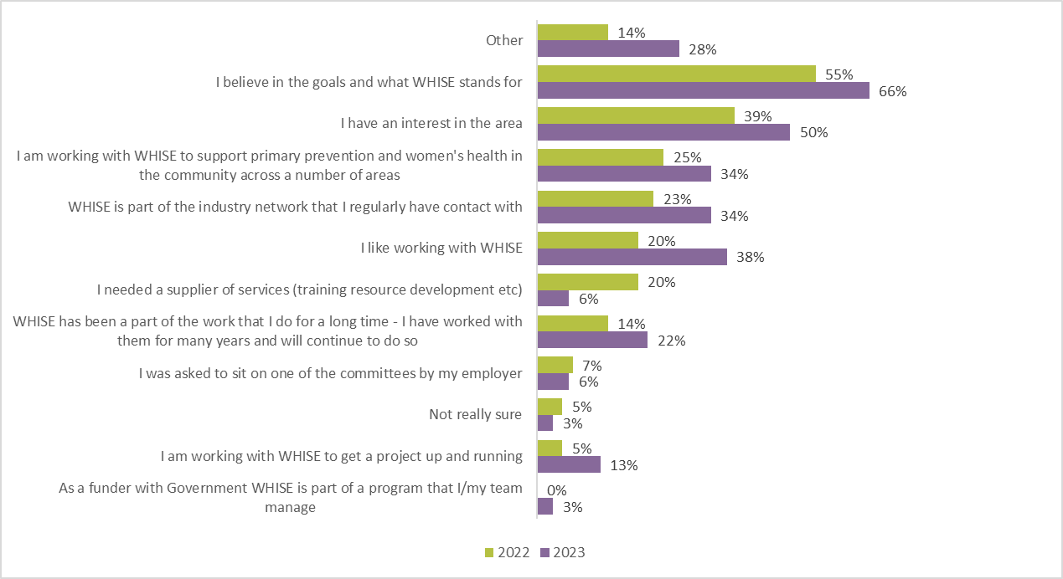
Figure 12. Motivations to work with WHISE in 2022 and 2023.

Perceptions and ratings of WHISE
Each year, WHISE measures how stakeholders and partners perceive WHISE. These responses provide an understanding of stakeholder satisfaction with WHISE’s services. As a community-facing organisation that works to create equity by educating and advocating for all women in the SMR, it is important that stakeholders perceive WHISE as trustworthy and believe that WHISE’s services are of high quality.

Recommend WHISE to a friend or colleague
One way of measuring perceptions is to ask respondents to rate (scale of 0-10) the likelihood that they would recommend WHISE to a friend or colleague.
In the 2023 survey, where 31 people responded to this question, WHISE scored a Net Promoter Score (NPS) of 32 which is a decrease of 17 points from last year’s survey (2022) which had 41 people respond to the same question. A NPS is a measure of customer, or in this case, stakeholder, loyalty to a company whereby a higher score is desirable (Qualtrics, 2021). According to global benchmarking data from Survey Monkey (which holds the NPS of 150,000+ organisations), the average NPS is 32 and the median NPS is 44, meaning, half of organisations have an NPS below 44 and another half score above 44 (Survey Monkey, 2021). WHISE’s NPS score in 2023 was therefore sits at the average NPS and therefore reflects high levels of satisfaction among stakeholders and partners (see figure 13).
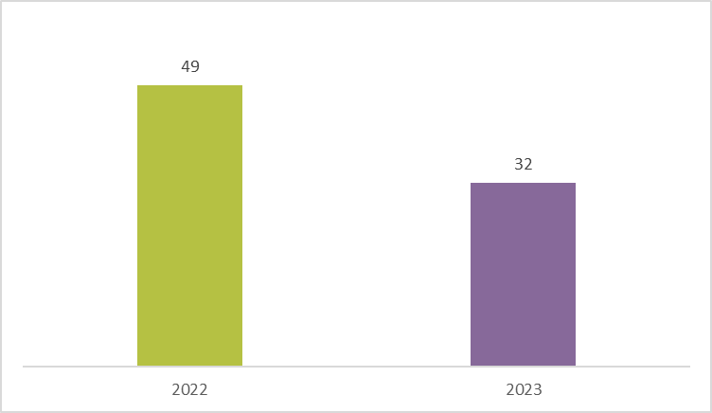
Figure 13. Net Promotor Scores from 2022 and 2023.
Figure 14 shows the proportions of respondents who endorsed each rating level in the 2022 and 2023 surveys. As can be seen, people were more likely to recommend WHISE in 2022, as the frequency of high ratings of nine and 10 decreased from 2022 (51%) to 2023 (39%). However low ratings between 0-5 also decreased from 2022 (6%) to 2023 (7%), whereas moderate ratings between of 6-8 increased from 2021 (41%) to 2022 (55%).
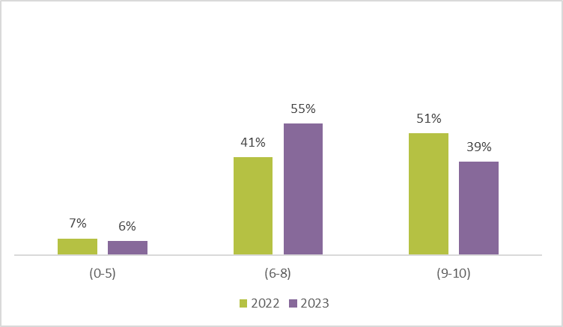
Figure 14. Likelihood of recommending WHISE to a friend or colleague in 2022 and 2023.
Figure 15 shows the 2023 ratings by people who have or have not previously been involved with WHISE. Looking at Figure 14, respondents who have previously been involved with WHISE are more likely to recommend WHISE to a friend or colleague. The higher rankings of eight, nine and 10 have been endorsed by a greater proportion of people who have previous involvement and therefore, first-hand experience of WHISE’s services and work.
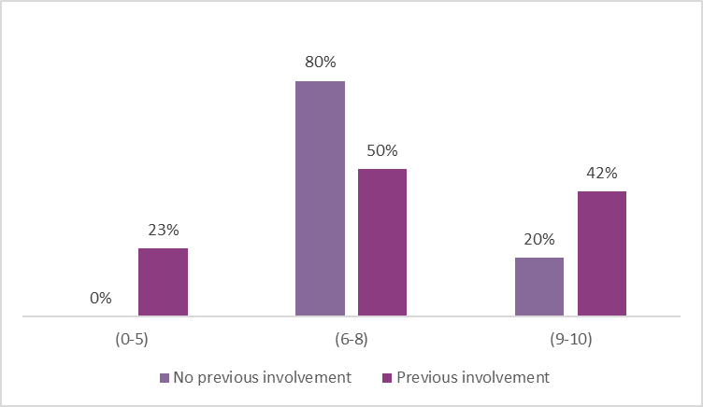
Figure 15. The likelihood of recommending WHISE to a friend or colleague disaggregated by previous involvement with WHISE (2023).

Quality of service
The quality of the service WHISE provides was also rated to measure how stakeholders perceive WHISE. Respondents were asked to endorse one of five rating options: very high quality, high quality, neither high nor low quality, low quality, or very low quality. In 2022 44 people answered this question, whereas 32 people answered this question in 2023.
As can be seen in Figure 16, no respondents rated WHISE’s service as being ‘very low quality’ or ‘low quality’ in 2022 or 2023. There was a higher number of respondents in 2023 that selected the ‘very high quality’ rating (38%), with only 9%of respondents selecting ‘neither high nor low quality’. Therefore, overall, stakeholders typically perceive WHISE’s quality of service to be high or very high quality which is an excellent evaluation of the work WHISE undertakes and services that are provided to stakeholders.
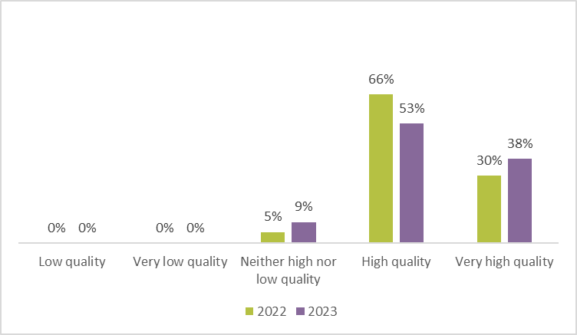
Figure 16.Quality of WHISE’s service in 2022 and 2023.
Figure 16 displays the 2023 quality of service ratings by people who have or have not previously been involved with WHISE. Compared with respondents who have not previously been involved with WHISE, those with previous involvement were more likely to endorse the high and very high quality ratings. These results are meaningful as they show that people who have direct experience working with WHISE perceive WHISE’s services and work to be of a very high quality.
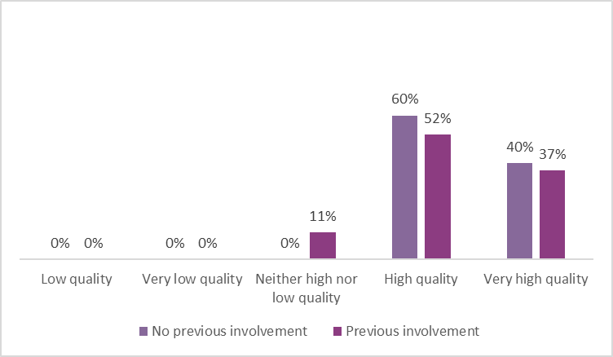
Figure 17. Quality of service ratings disaggregated by previous involvement with WHISE (2023).

Words associated with WHISE
A third way that perceptions of WHISE are measured is by asking respondents to select one or more words they would associate with WHISE. In 2021, 72 people answered this question and in 2022, 44 people answered this question.
Figures 18 and 19 display the words frequently selected by respondents in the 2022 and 2023 surveys. The larger words indicate a higher frequency of endorsement while smaller words indicate a lower frequency of endorsement. What stands out when looking at Figures 18 and 19 are the words collaborative and professional. Supportive, empowering, inclusive, and positive relationships were also frequently selected by respondents in both 2022 and 2023 surveys. In the 2023 survey the words Collaborative, Professional, and Feminist were additional words that appeared more frequently than the 2022 survey.
These words demonstrate that stakeholders perceive WHISE to be a service that works positively with its partners while also empowering and building the capability of others. The frequent selection of the word ‘inclusive’ in the 2022 and the 2023 survey, is meaningful as WHISE is a service that also seeks to promote and increase intersectional gender equality in the SMR.
In 2023, respondents listed the following additional words associated with WHISE:
- Help group for women suffering from domestic violence
- I have no idea
- View respondent's answers
- Creative, Unapologetic, Courageous
In 2022, respondents listed the following additional words associated with WHISE:
- Engaged, Influential, Receptive
- A strong solid foundation to work with. Resourceful. Intelligent. Courageous.
- I did not tick feminist as I think they are inclusive of all. Also, they are very proactive, rather than reactive

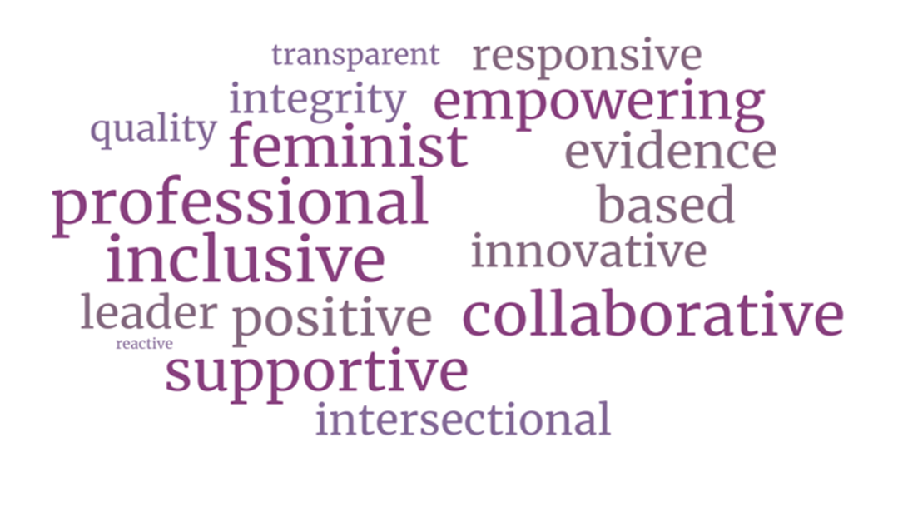
Figure 18. Words associated with WHISE in 2023.

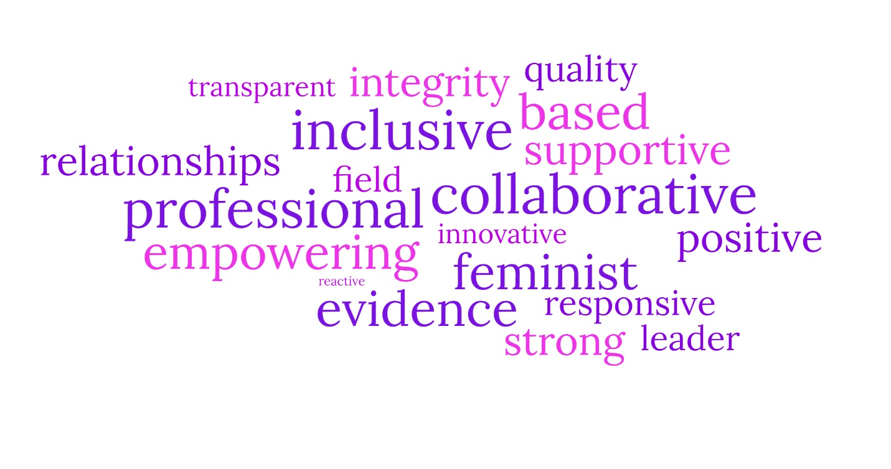
Figure 19. Words associated with WHISE in 2022.

Issues and agendas addressed by WHISE
In addition to learning about how and why stakeholders have engaged with WHISE, the survey asked about the issues and agendas stakeholders were aware that WHISE had presented on and/or produced papers on. This provides an indication of WHISE’s reach, presence, and leadership. Comparative data has not been provided from 2022 as the issues and agendas are not the same each year and therefore, only the responses from the 28 people who answered this question will be presented.
A list of 33 issues and agendas were presented, and respondents could select one or more that they were aware of. The issues and agendas were:
- Workforce Planning for the South Metro Region - Prevention of Violence Against Women
- Gender analysis of the State Budget 2023-24
- Advocacy undertaken to address gender segregated labour markets in legacy industries (i.e., construction, engineering, STEM sectors, electrical trades)
- 16 Days of Activism
- Sexual and Reproductive Health Week social media campaign
- Social media campaign to increase cervical screening among LGBTIQ+ people
- Women's Health Week social media campaign
- Respectful Relationships Initiative (schools) and Critical Friends Network
- Introduction to Understanding Family Violence training
- Introduction to Gender Equality training
- Preventing Family Violence First Aid training
- Sexual harassment in the workplace training
- Capacity building sessions for youth workers
- Active Bystander training
- Healthy & WHISE Women training
- TAC L2P Learner Driver Mentor Program Training
- Learning Forum - Men and Masculinities
- Learning Forum - Biological Sex, Gender, and Mental Wellbeing
- "Hot" Topic - Menopause Learning Forum
- Learning Forum - transgender and gender diverse inclusive practice
- Aligning Personal with the Professional Conference
- Cultural competency training
- Learning Forum - Reproductive Coercion
- Learning Forum - PCOS and the weight of stigma
- Learning forum - Applying an intersectional gender lens to PVAW practice
- Capacity building session on becoming a medical abortion provider
- Gender pay gap information session
- Submission into Federal Government’s Draft National Strategy into the Care Economy
- Submission to the Senate Standing Committee on Education and Employment on Gender Equity in Skills policy
- Submission to the Victorian Government's inquiry into the rental and housing affordability crisis
- Submission to the Senate Inquiry on Universal Access to Reproductive Healthcare
- Medical Abortion case study
- International Day Against Homophobia, Biphobia, and Transphobia (IDAHOBIT) social media campaign

Figure 20 displays the issues and agendas that 68% of respondents stated that they were aware of. As can be seen, 57% of the people were aware that WHISE had produced work in relation to 16 Days of Activism, 54% of people were aware of our Sexual and Reproductive Health Week social media campaign. Respondents were also aware of our Introduction to Gender Equality training (50%), and our Women’s health week social media campaign (46%). The gender analysis of the State Budget 2022-23 was also highlighted (43%).
In 2022, the prominence of issues and agendas varied across submissions, papers, campaigns, and workshops. No clear trend was evident, as both the most and least visible topics fluctuated. Whereas in 2023 there was a clear trend of what issues were more visible to our stakeholders. In 2023, it was apparent that the most visible issues and agendas that WHISE had worked on were campaigns and webinars, whereas almost all the submissions and papers that WHISE has produced were below 7%. This suggests that WHISE need to be more strategic with the ways that we promote our submissions and papers through social media and EDMs.
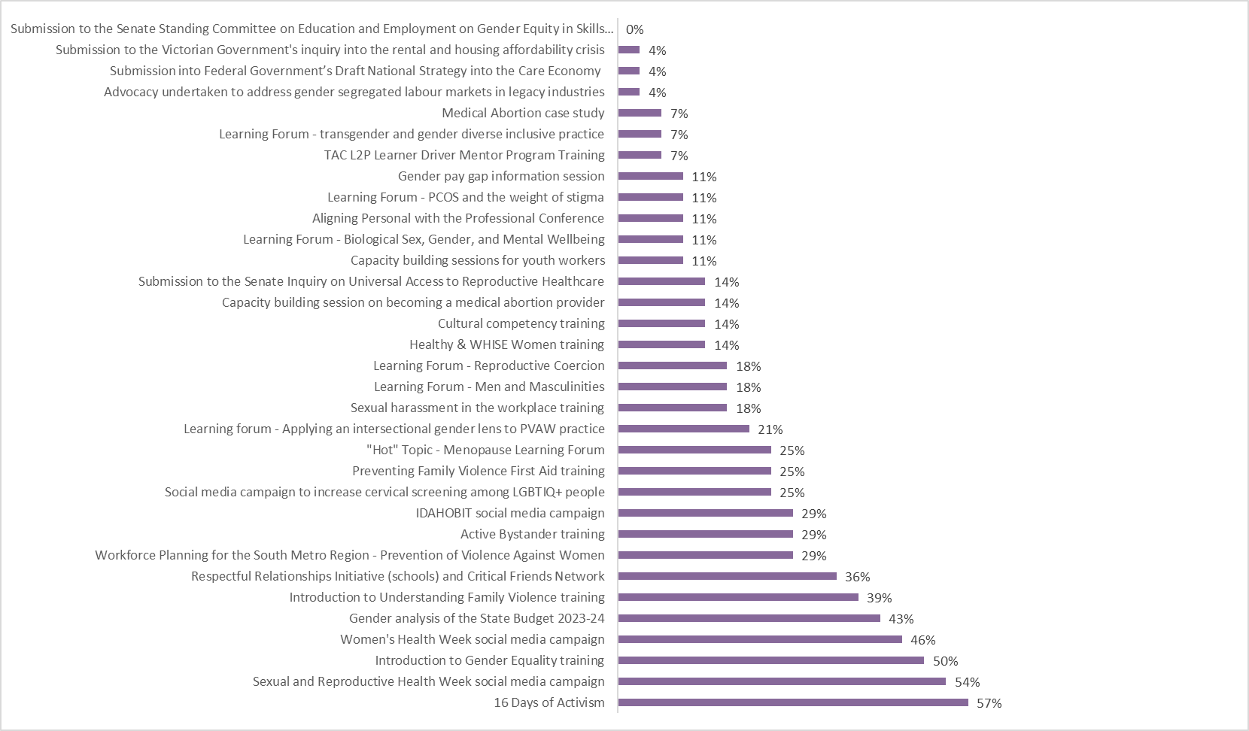
Figure 20. Issues and agendas WHISE have focused on that respondents were most frequently aware of in 2023.

Suggested priorities for the next 12 to 18 months
The survey asked what priorities WHISE should have over the next 12 to 18 months of its work, with 19 people who responded to this question. Three main themes arose from the responses: PVAW, gender equality, mental health, and intersectionality.
Five respondents highlighted the need for more work on issues relating to PVAW. Two responders simply stated PVAW, whereas one other person said, “drivers of family violence, by engaging men for change”, with another person stating they would like to see content on helping, " women from violence in the home and workplace”. One respondent was more specific and said:
I think WHISE has always had a clear vision of the work and priorities for Women's Health. I think the ongoing commitment to advocating for primary prevention as an integral part of the FV response and as such continue the advocacy for appropriate and sustained funding to enable initiatives to be developed with a long-term focus as we know shifting gendered drivers of FV requires a sustained response.
Three respondents requested that WHISE work on issues concerning gender equality- themes ranged from workplace equality to female self-advocacy. One person asked WHISE to work on issues addressing workplace issues relating to “cultural family dynamics and impact on women to access to flexible employment to support women's independence”.
Two respondents requested that WHISE work on issues concerning mental health. One person asked WHISE to work on issues relating to “mental health’s relationship to climate change and the impacts on Women’s Health and Wellbeing”. Another three people suggested content based on intersectional themes, for example person said, “continue focussing on women with disabilities and other communities confronted to intersectional forms of discrimination”, whereas another person said, “promoting the International Day of Zero Tolerance to FGM/C in South East region on the 6th of February each year”. One person suggested content based on SRH:
Advocacy for affordable contraception and abortion, gender diversity and inclusion.
Other comments included:
I am of the belief that WHISE are connected to the needs of the community and best to prioritise the work that needs to be undertaken.
Perhaps being clearer on their inclusion of gender diverse people as well as 'women'
Staff retention
Keep up the good work you are doing

Comparisons with 2021 responses
The same question was included in the 2022 Annual Stakeholder Impact Survey which was answered by 23 people, compared to 19 in 2023. The most frequently requested issues for WHISE to address in 2022 were PVAW, GE, SRH, intersectionality, and capacity training and engagement, which is somewhat consistent with those in 2023.
Seven respondents requested that WHISE work on issues concerning GE. While in 2022, this was the one of most frequently requested issue, in 2023 it was indirectly raised through themes that encompassed GE values, such as self-advocacy and workplace equality.
In 2022, there was an increased number of people who requested work and advocacy relating to issues of PVAW, such as concerns about police and action responses. Similarly, in 2023 issues related to PVAW were the most frequent request, with themes ranging from workplace accessibility and masculinity. Furthermore, in 2022, SRH issues were suggested by three respondents, whereas it was only mentioned once in 2023.
Three respondents suggested that WHISE should prioritise “intersectionality” and continue to incorporate this value in its work in 2022. This reflects a continual need and desire for intersectional thought and practice in our work to create stronger evidence-base processes and policies. For instance, in 2023 intersectional themes was suggested by three people.

Areas of capacity or capability building WHISE should provide services for
Respondents were asked whether there were any specific areas of capacity or capability building (including training) that they thought WHISE should provide services for in our region. In 2023, 10 people responded to this question. Two people stated that they were unsure, whereas another two people stated that their answer for the previous question is the same for this this question. One person simply wrote “PVAW”.
Specific suggestions included:
Provision of accessible health services.
Gender equity in early childhood.
Yes, in collaboration with FARREP, FGM/C information session for Maternal and Child Health Nurses in City of Casey.
I think WHISE provides extensive training, it would be great to have the funding to expand and develop the FV First Aid training in Southern Melbourne. It is an accessible model of learning for many communities and organisations taking their first step to understanding the issue that impacts us all.
Gender Impact assessments by applying an intersectional lens to Gender Equity.
Events and resources for young people.

Comparisons with 2021 responses
In 2022, a total of 18 people responded to this question, revealing three main themes: Gender Equity (GE), Prevention of Violence Against Women (PVAW), Sexual and Reproductive Health (SRH), and intersectionality. Within the theme of Gender Equity, three respondents suggested areas for capacity or capability building. Additionally, three respondents either encouraged WHISE to continue providing current services or suggested training services that WHISE already offers. Lastly, four respondents recommended capacity or capability building services under the theme of Prevention of Violence Against Women, such as bystander intervention training.

Despite the small response turnout, similarities can be seen when comparing the responses from 2022 and 2023. It appears that GE and PVAW remains to be areas of concern for stakeholders as they continue to request training sessions on this topic. In 2022, there was focus on support services for women who may have been affected by extra stress during the pandemic, however there was no COVID related themes in 2023. Lastly, stakeholders from both surveys encouraged WHISE to continue to provide our current services, indicating WHISE is sustaining effective capacity building opportunities for our region.

General feedback
Respondents were asked whether there were any specific feedback, concerns or questions that they would like to provide concerning our practises, services, and work, with nine people responding to the question.
The comments included general positive feedback:
Keep doing the great work you are doing!
Thank you so much for the work you do!
It's always a pleasure working with the WHISE team, and I look forward to continuing to build the collaboration and partnership across Southern Melbourne.
I attended the WHISE Better Together conference in August and that was a fantastic day to hear from a range of speakers on different topics.
Love your work and your workplace culture!
Some respondents provided some specific feedback for our services:
I think more people need to be aware of its existence & services.
Information on how most of the feel-good initiatives are cover ups and promoting Big Pharma, One World Order and dividing and dumbing down people.

Concluding remarks
The fifth annual Stakeholder Engagement and Impact Survey was completed by respondents who represented a diversity in organisations and professional roles. While only 41% of respondents were members of WHISE, 84% had some level of involvement with WHISE's work and activities. Therefore, they were familiar with our work and able to answer questions about the quality and reach of our work with a level of authority.
From year to year, the biggest motivating factor remains to be that people believe in WHISE's goals and what we stand for which shows that our values and mission draw people to us. The NPS of 32 reflects a high level of satisfaction among stakeholders which was also demonstrated in the high quality of service ratings and willingness to recommend WHISE to a friend or colleague.
Stakeholder feedback indicates that WHISE is perceived as an empowering service promoting intersectional gender equality and equity, which is strongly aligned with our mission and desired public image. Collaboration was also highlighted as a key association with WHISE, underscoring the ongoing work with our community and stakeholders.
Themes related to the prevention of violence against women and family violence were prominently requested by respondents, demonstrating their continued passion for WHISE's work. Responses to inquiries about future focus areas and services emphasised important social change, with a greater emphasis on issues and populations intersecting with sexual and reproductive health (SRH) and prevention of violence against women (PVAW). This consistency with the 2021 and 2022 survey indicates stakeholders' interest in seeing WHISE explore themes reflecting social change and underscores the value of our work to the community.
In responses regarding capacity building and training, intersectionality, GE, and PVAW emerged as common themes. These requests recognise the invisibility of women from diverse backgrounds in health and domestic violence literature and highlight the need for policies and procedures to address the complex intersections of gender, race, disability, ethnicity, and immigration status. It also acknowledges the ongoing work required to address violence against women and achieve gender equality.
While these results demonstrate stakeholder admiration and trust in WHISE, they also highlight areas for improvement. For instance, there is a need for clearer promotion of WHISE's role, as stakeholders have expressed uncertainty about the organisation's work. An example of this is the request for gender Impact assessments through an intersectional lens, which is already a part of our existing work. This challenge appears to be common among women's health services, indicating a broader need for clarity regarding their roles among stakeholders and the community.

References
Ghafournia, N. & Easteal, P., 2018. Are immigrant women visible in Australian domestic violence reports that potentially influence policy?. Laws, 7(32), pp. 1-16.
Maher, J. & Segrave, M., 2018. Family violence risk, migration status and 'vulnerability': hearing the voices of immigrant women. Journal of Gender-Based Violence, 2(3), pp. 503-518.
Qualtrics, 2021. What is Net Promoter Score (NPS)? Definition & Examples. [Online]
Available at: https://www.qualtrics.com/au/experience-management/customer/net-promoter-score/
[Accessed 27 October 2021].
Survey Monkey, 2021. What is a good Net Promoter Score? And how does it vary across industries?. [Online]
Available at: https://www.surveymonkey.com/curiosity/what-is-a-good-net-promoter-score/
[Accessed 27 October 2021].

