Critical Friends Network

Evaluation of Intersectional Gender Equality and Family Violence Training

Background
The Critical Friends Network was revitalised in 2023 through the tireless efforts of Yihan Li, a Health Promotion Officer at Women’s Health in the South East (WHISE). During this period, Yihan recruited several new potential Critical Friends. Before connecting them with schools, the protocol required building their capacity in Family Violence 101 and intersectional gender equality. The new recruits then received training in Respectful Relationships Education and how to serve a Critical Friend.
This report evaluates the initial training on family violence and intersectional gender equality provided to the new group of prospective Critical Friends. The training session, held online by Heidi Waterson and Yihan Li, took place on Wednesday 10 April 2024, with 19 people.

Who completed the survey?
Of the 19 people who attended the training session, 10 people (80% women, 20% men) completed the pre-session survey. Of these, four people completed the post-session survey which represents a response rate of 40%. Twelve weeks following the training, three people completed the follow-up survey.
The participants worked in sectors in government and public sector, health and wellbeing, and education and early learning. Their professional roles were diverse, encompassing several fields, including:
- Health and wellbeing roles– e.g., Health Psychologist, and Health Promotion Officers.
- Education and training roles – e.g., Educator, and Training and Education Worker.
- Youth and community services roles– e.g., Children and Youth Coordinator, and Youth Projects and Partnerships Officer.
- Respect and relationships roles – e.g., Respectful Relationships Liaison Officer.
- Leadership roles – e.g., School Principal.

Findings

Changes in understanding
Figure 1 shows a significant improvement in participants’ understanding of how family violence is defined. Initially, before the training, a majority of the participants rated their understanding as ‘high’, with a notable portion rating it as ‘low’, and one participant indicating a neutral level of understanding. After the training, there was a marked increase in the proportion of participants rating their understanding as ‘very high’ with a small portion still rating it as neutral. Twelve weeks following the training, the understanding levels were sustained with a majority maintaining ‘very high’ and ‘high’ ratings, indicating a lasting improvement. The data shows a clear trend of increased understanding post-training, with these gains largely maintained in the follow-up period.
Looking at Figure 2, there was a large improvement in participants’ understanding of the different forms of family violence. Before the training, the understanding levels varied from ‘low’ to ‘very high’ with most participants indicating they had a ‘high’ understanding. Following the training, there was a noticeable shift, with all participants rating their understanding as ‘very high’ or ‘high’, demonstrating a substantial increase in comprehension. This improvement was largely maintained in the follow-up period, where the majority continued to rate their understanding as ‘very high’ or ‘high’, indicating the lasting impact of the training session on their awareness and understanding of the different forms of family violence.
There were notable changes in participants’ understanding of why family violence happens (i.e., the drivers of family violence) following the training (see Figure 3). Participants entered the training with a decent understanding of this topic with most rating their understanding as ‘high’. Though some participants had a moderate level of understanding. After the training, the understanding improved significantly, with all participants rating their understanding as either ‘very high’ or ‘high’, showing a clear increase in their knowledge. In the follow-up period, this improved understanding was largely sustained, as the majority continued to rate their understanding as ‘very high’ or ‘high’. This indicates that the training had a lasting positive impact on participants’ comprehension of the drivers of family violence.
As can be seen in Figure 4, there were significant changes in participants’ understanding of how gender inequality is linked with family violence. Again, the majority of participants had a high level of understanding, though some had selected ‘low’. This shows that while many participants had a good level of understanding, there were still notable gaps. Following the training, there was a marked improvement, with a substantial proportion rating their understanding as ‘very high’ and the remainder as ‘high’, indicating a significant enhancement in comprehension. In the follow-up period, this improved understanding was largely maintained, with most participants continuing to rate their understanding as ‘very high’ or ‘high’. This suggests that the training was beneficial for the participants’ awareness and understanding of the connection between gender inequality and family violence.

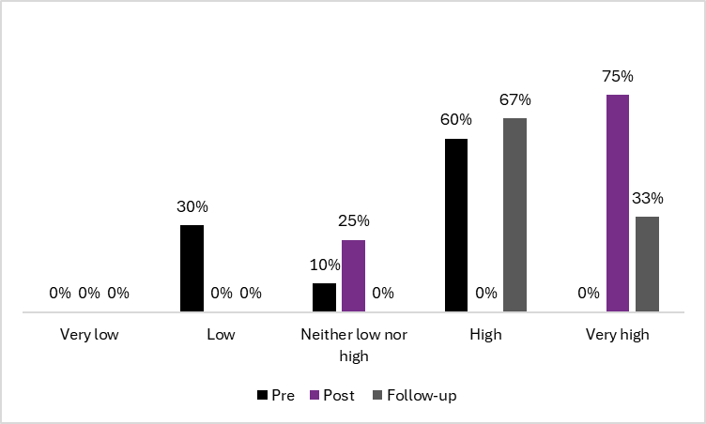
Figure 1. Pre, post and follow-up ratings of understanding how family violence is defined.
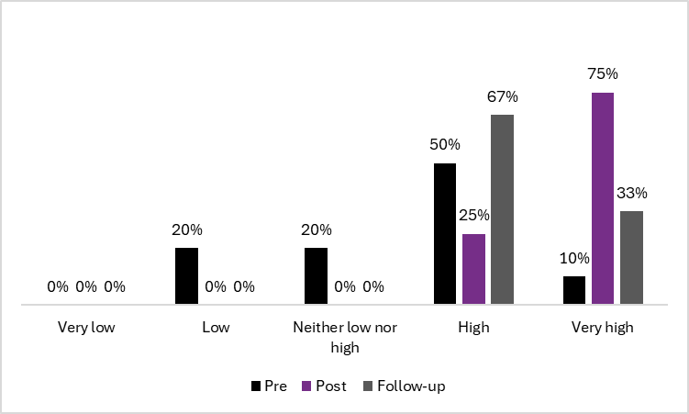
Figure 2. Pre, post and follow-up ratings of understanding the different forms of family violence.
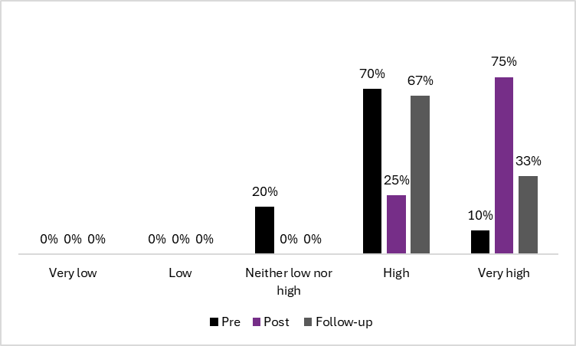
Figure 3. Pre, post and follow-up ratings of understanding why family violence happens.
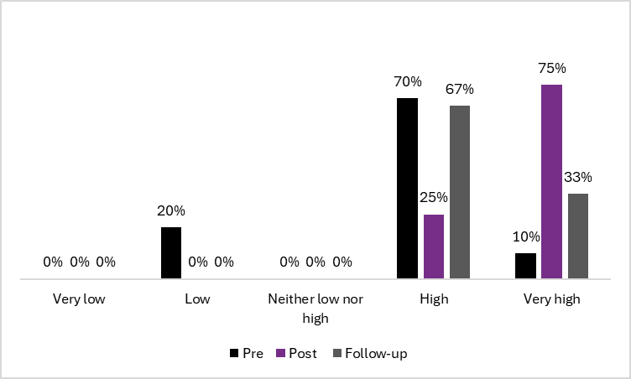
Figure 4. Pre, post and follow-up ratings of understanding how gender inequality is linked with family violence.

Changes in confidence
Figure 5 shows there was a notable improvement in participants’ confidence to talk about the link between family violence and gender equality in schools. Initially, the participants’ confidence levels varied ‘not at all confident’ to ‘confident’. After the training, participants were more confident with the majority rating themselves as ‘confident’ or ‘very confident’. This trend continued in the follow-up period, where most participants maintained their ‘very confident’ or ‘confident’ ratings, indicating that the training had a positive impact on their confidence to discuss the link between family violence and gender equality in educational settings.
The responses in Figure 6 illustrate significant changes in participants’ confidence in considering young peoples’ diverse identities and experiences when supporting schools using a whole-school approach. Participants’ confidence levels were varied before attending the training session. A notable proportion of participants were not very confident in this area. After the training session, there was a marked improvement, with most participants rating their confidence as ‘confident’ or ‘very confident’. This enhanced confidence was largely maintained in the follow-up period, where the majority continued to rate themselves as ‘confident’ or ‘very confident’, with some still feeling ‘fairly confident’. This indicates that the positive impact of the training was sustained.
As can be seen in Figure 7, there was an increase in participants’ confidence to take action against family violence in their role as a Critical Friend. Confidence varied widely before the training session with ratings from ‘not at all confident’ to ‘very confident’. This distribution suggests that many participants lacked the confidence to effectively take action against family violence in their roles. After the training, there was a notable increase in confidence, with all participants rating themselves as ‘confident’ or ‘very confident’. This improvement reflects a substantial gain in confidence due to the training. In the follow-up period, while most participants maintained high confidence levels, with many rating themselves as ‘confident’ or ‘very confident’, there was a slight decline for one participant, indicating variability in sustained confidence over time. Overall, the training had a positive impact on participants’ confidence to act against family violence.
The presence of ‘not so confident’ and ‘fairly confident’ ratings at follow-up suggest that further support would be helpful to maintain the confidence of some participants.

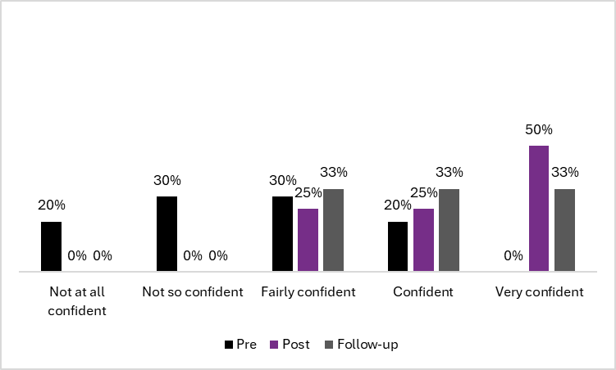
Figure 5. Pre, post and follow-up ratings of confidence to talk about the link between family violence and gender equality in schools.
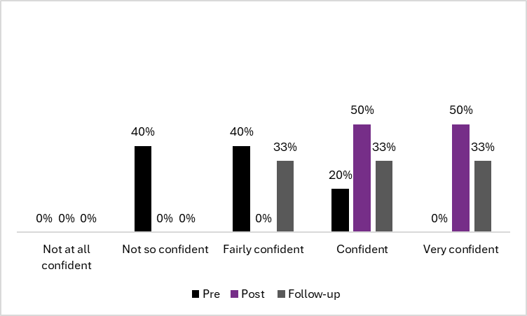
Figure 6. Pre, post and follow-up ratings of confidence to consider the diverse identities and experiences of young people when supporting schools using a whole of school approach.

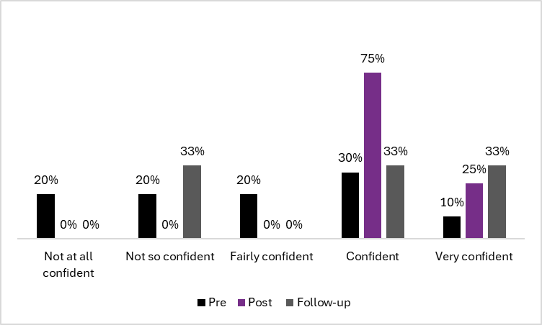
Figure 7. Pre, post and follow-up ratings of confidence to take action against family violence in your role as a Critical Friend.

Has this training improved their role as a Critical Friend?
One participant felt the training could have been delivered at a higher level, stating, “I felt like this training could have been delivered at a higher level. I felt like I already had knowledge/ understanding on the content that was delivered during the training.” This suggests that the training did not meet their expectations in terms of depth and new information.
Another participant had a more positive experience, however, simply noting, “I think it has,” indicating that they found the training beneficial but did not elaborate on specifics.
A third participant emphasised the development of their understanding, with a comment, “Develop a better understanding.” This suggests that for some, the training successfully enhanced their confidence and ability to fulfil their role as a Critical Friend.

Further support
Requests for further support highlighted a desire for practical examples, ongoing skill development, and advanced training. One participant expressed the importance of real-world applications by stating, “It’s always good to hear examples/case studies of how different schools implement their RR program.” This suggests a need for concrete illustrations of successful practices.
Another emphasised the necessity of continuous professional development with the succinct suggestion to “Keep upskilling.”
Additionally, the preference for experiential learning was noted with the comment, “Hands on experience.”
Finally, there was a clear call for more in-depth learning opportunities, as one respondent requested “future training sessions that discuss the prevention of family violence at a more advanced level.”
These responses collectively indicate a need for ongoing, practical, and advanced support to enhance their effectiveness in their roles.

