Evaluation Report for the Size Inclusive Practice Forum

Background
The main objective of this webinar was to support health practitioners at both ends of the mental health spectrum to promote size-inclusive practice in their work. No matter whether we work in prevention or response, we have a common goal to improve the health and wellbeing of the community. How we do this may look different, but our core purpose typically involves promoting health and reducing barriers to access. One such pervasive barrier to access is sizeism.
We're championing a size-inclusive approach to health because it's not just morally right; it's scientifically sound. While weight-centred practices drive people away from health, size-inclusive practices challenge biases and promote health. Embracing size-inclusive practices as our core business reflects our commitment to treating people of all sizes, genders, ethnicities, abilities, and identities with dignity and respect.

The objectives of the workshop are to:

Improve participants’ knowledge and understanding of sizeism as a gendered barrier to achieving health outcomes (including mental health)

Improve participants’ knowledge and understanding of size-inclusive practice, with a focus on prevention (I.e. size-inclusive health promotion)

Improve participant’s knowledge and understanding of the link between gender transformative and size-inclusive practice.

Improve participants’ confidence in applying size-inclusive practice principles to their work, drawing on the Better Health Network size-inclusive practice tool, and prevention items in the National Eating Disorders Strategy.

Who attended this session?
A total of 69 people registered for the session and 29 people attended on the day, with 27 (46%) attendees completing the pre survey. Furthermore, of the 29 attendees, 24 attendees completed the post survey with an 84% completion rate. It should be noted that only 5 attendees completed the follow-up survey, so please take this into account when reading the evaluation below. The pre survey indicated that 93% of attendees identified as female, compared to 4% of attendees identified as Male, and 4% of people identified as non-binary. No demographic data was recorded through the post survey, whereas 100% of attendees identified as female in the follow-up survey.

Findings
Overall ratings of knowledge and understanding
Figures 1 to 4 show that there were changes in understanding and knowledge from pre- to post to follow-up. Worth highlighting is the increased understanding of how sizeism disproportionately impacts women’s health outcomes, with the majority of attendees selecting high to very high (95%; see Figure 1). This question also received the highest proportion of high responses, with 77%. Similarly, the questions that asked about their understanding of how to incorporate size-inclusive practice into your existing work, received the second largest increase in understanding, with the majority of respondents selecting high to very high (86%; see figure 4).
Figure 2 demonstrates the session ratings for the question that asked to rate their understanding of the link between gender transformative practice and size-inclusive practice, with the majority of attendees selecting high to very high (82%). The question that asked about their knowledge and understanding of the link between gender transformative practice and size-inclusive practice received the lowest increase. However, this question also appeared to have the majority of attendees selecting high to very high (77%; see figure 3).

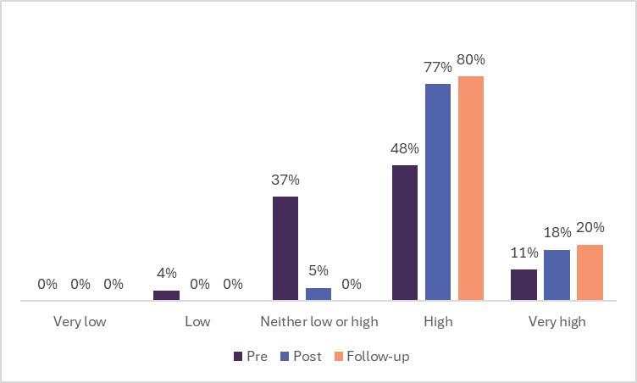
Figure 1. Pre and post session ratings of understanding of how sizeism disproportionately impacts women’s health outcomes.
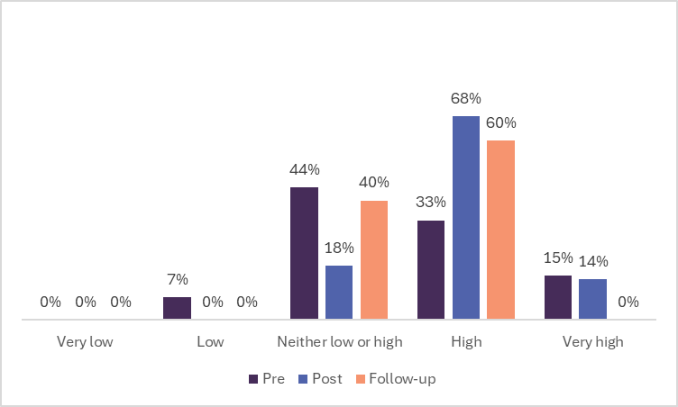
Figure 2. Pre and post session ratings of understanding of how sizeism disproportionately impacts people of colour.

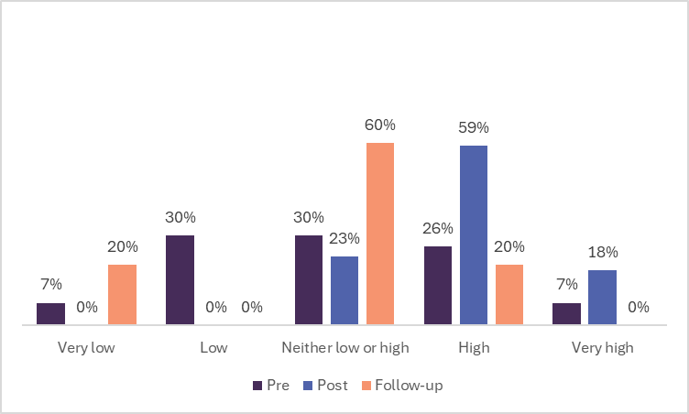
Figure 3. Pre and post session ratings of understanding of the link between gender transformative practice and size-inclusive practice.

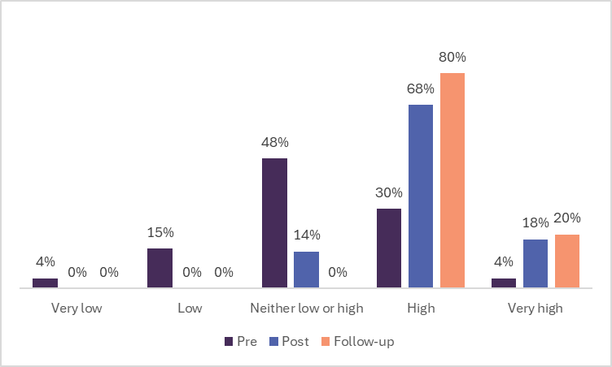
Figure 4. Pre and post session ratings of understanding of how to incorporate size-inclusive practice into your existing work.

Overall ratings of confidence
Figures 5 demonstrates that there were changes in confidence from pre to post. This question asked about their confidence in applying principles of size-inclusive practice to their work. As can be seen below, there was over half of participants who felt their confidence increased to confidence or very confidence (64%). Furthermore, the follow-up survey demonstates that the majority of attendees retained their confidence with 60% selecting confident to very confident.

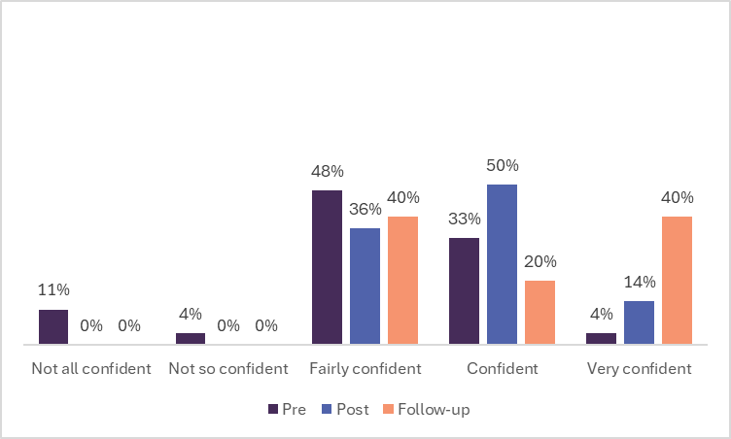
Figure 5. Pre and post session ratings of confidence to apply principles of size-inclusive practice to your work.

Indicator framework
The indicator framework questions were only asked in the post survey; therefore, only the participants who completed the post survey had the opportunity to answer these questions. As can be seen, there was a clear increase in confidence in applying a gender lens at work, with 21 attendees (of the 22 participants) answering this question. This question received a high proportion of attendees who selected confident to very confident (60%), with the majority of participants selecting Confident (57%; figure 6). Figure 7 demonstrates that asked the question; to rate their confidence in applying knowledge of a gendered approach to improve mental health and wellbeing at your work, also received a high proportion of attendees who selected confident to very confident (60%), with the majority of participants selecting Confident (45%; 20 out of 22 participants answered this question).

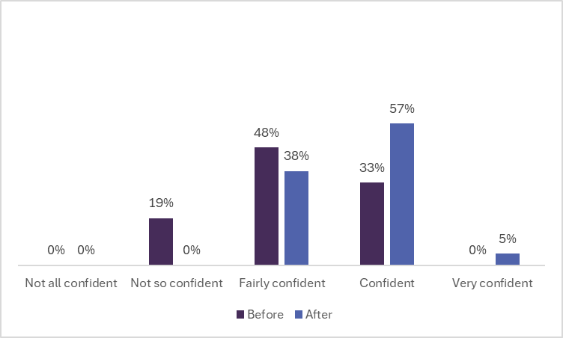
Figure 6. Before and after session ratings of confidence to apply a gender lens at work.

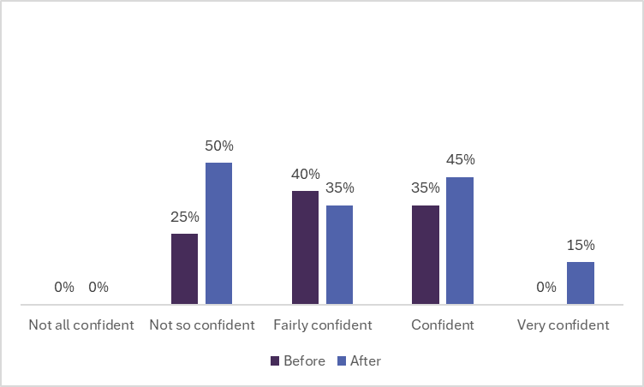
Figure 7. Before and after session ratings of confidence to apply knowledge of a gendered approach* to improve mental health and wellbeing at your work.
Key learnings
Of the 22 people who answered the quantitative question, 12 people (55%) answered this short answer question on key learnings and takeaways. The most common theme (n=3) based on key learnings/takeaways was the need of inclusive practice within areas of health as a standard practice. One person specifically said to be ‘Gender transformative size inclusive lens.’ The other 9 responses varied in themes, personal reflection, to intersectionality, to using this knowledge in practice:
I knew a lot of the information already; however, I really enjoyed the discussion at the end around planning open spaces for people with larger bodies.
The use of language in our work and discussions with the community.
It was really encouraging to see this emerging field of research and how it ties with intersectionality. In particular, it was eye opening to see how this is being applied in practice - especially thinking about BHN's toolkit and WHISE's Healthy Bodies, Healthy Relationships initiative.
Supporting people of all sizes to take care of their health and wellbeing, without weight stigma.
The importance of our own reflection and how we can take small steps toward change.
Where to find resources and more information.
Through the Better Health Network resource - working with young children at an appropriate level for their development
Consideration needs to be given to how we promote health in women and their children without causing harm.
How weight stigma disproportionately impacts people from culturally and linguistically diverse backgrounds.
Applications of learnings
Of the 22 people who answered the quantitative question, 12 people (55%) answered this short answer question on whether participants feel confident to apply the learnings from this session. One person simply wrote ‘yes’, whereas another five people specifically stated how they felt confident:
Yes, I could. Not as relevant to my current projects but will use in the future. Also, I can use the information and webinar to build capacity within other areas of council.
Yes, as a Nutrition online learning tool is currently being developed.
Yes, but still refer to research to practices to confirm.
Yes, as a size inclusive practitioner I am already doing this work, but it will allow me to see even more areas of need.
Yes, to Review of messaging provided re health and wellbeing.
Another three participants reported that they were unsure or in between yes and no, however their responses were evidently filled with curiosity and willingness to embrace new knowledge:
Yes and no - I think my practices will be impacted e.g. using size inclusive imagery. However, I wouldn't be confident to create a standalone size inclusive project.
I think so, the main way I will try to apply these learnings will be encouraging settings to not have their traffic light food labelling outwardly facing.
I'm not so sure if I'm confident to apply the learnings as sizeism is a very new concept for me. However, the webinar gave me lots of food for thought. I'm looking forward to sharing info with my colleagues!
Two people wrote about how they feel confident to apply these learnings with different demographics:
I could apply the learnings to advocate for women from migrant and refugee background.
When developing presentations for young people.
One person demonstrated how they now feel confident to integrate these learnings in their existing work:
I am also working closely on the Gender Equality portfolio which allows me to implement gender equity principles and inclusive practices more readily.
Requests for support
Of the 22 people who answered the quantitative question, 9 people (41%) answered this short answer question on whether attendees needed extra support to apply these learnings. By far, most people reported the need for resources (n=4). Comments included:

Resources for different departments of council on applying a size inclusive lens in their area e.g., health promotion teams, youth teams, ageing positively team, urban planning, open space planners, sport, and recreation, etc.
Get the resources out into the community through the Local Councils and Community Health Centers. More needs to be done in the media and also in schools.
Continue to provide learnings and resources relating to incorporating size inclusive practice within our existing health priorities and projects.
Three people simply said for WHISE to continue to do what they have been doing, with one person suggesting a specific mode of support, which is to review existing pieces of work.

Feedback
Of the 22 people who answered the quantitative question, 12 people (55%) answered this short answer question on feedback for the facilitators. answered this short answer question on whether they have feedback for facilitators. By far, most people reported that the facilitators and the session was ‘great’, ‘informative’ ‘passionate’, and ‘engaging’. Other comments included:
No feedback other than thank you so much for an informative session :-) Charlotte was a great presenter and communicated all that research in such an easy-to-digest manner - I can't begin to imagine how difficult that task would've been!
Although the feedback overall was overwhelmingly positive, three participants expressed concerns that the content may have been overly text-driven. They suggested that incorporating case studies and participatory activities would have balanced the presentation more effectively. However, one person mentioned that they would have appreciated more definitions at the beginning of the presentation. Conversely, another participant felt that the presentation was overly academic.
Both highly engaging and easy to listen to. Conveyed content in a relaxed and easy way. It would've been good to have some more definitions at the beginning i.e. weight bias and weight stigma etc.
The first section presented by Charlotte (brilliantly spoken Charlotte) was a bit too academic, it was hard to fully engage. Although I understand the importance of leaning on the evidence base

Follow-up Findings
Application of knowledge
Of the 5 people who answered the quantitative question, 3 people (60%) answered this short answer question on whether attendees felt that they were able to apply these learnings to their role. Comments are below:
Yes, in developing a nutrition training program. We used the BHN Size Inclusive document to assist with checking the language we were using and this was shared with the Dietitians involved in the program to ensure we were all of the same understanding.
Yes, have been more mindful of conversations I am having with settings. I have also re-watched it.
Yes, by reminding people that size is not always a choice. There are many factors as to why a person is obese or anorexic. We are there to support, not judge.
Additional feedback
Of the 5 people who answered the quantitative question, 3 people (60%) answered this short answer question on whether attendees felt this webinar has had an impact of their work or personal life. Comments are below:
Definitely, it highlighted the importance of the use of language, provided opportunities to incorporate this into conversation within other programs in our service.
Whilst I had started work in this space already, this solidified my understanding and ability to talk about it to people.
I don’t think so as I have always been conscious not to judge people based on their size.

