Evaluation of the Gender and Mental Wellbeing Health Planners' Forum

Background
On 28 November, 2023, WHISE ran a forum with health planners from the 10 local government areas within the Southern Metropolitan Region. The aim was to identify synergies between mental health promotion and gender transformative practice in the municipal health and wellbeing plans.
The first part of the forum focused on increasing participants’ understanding of mental wellbeing as a health priority. The content covered mental health outcomes in the Southern Metropolitan Region, legislative levers and policy frameworks for local government, opportunities to align mental wellbeing within their health and wellbeing planning and action, and examples of this in practice.
The second part focused on increasing participants’ confidence to apply knowledge of gender transformative mental health promotion to municipal health and wellbeing planning, policies, activities and promotion.

Changes in understanding
Pre and post surveys measured whether there were changes in understanding of:
- Mental health promotion as a critical health and wellbeing priority area
- How the determinants of mental wellbeing extend across all social determinants, and all health priority areas
- The local context and needs analysis for gender transformative mental health promotion in the Southern Metropolitan Region
- Legislative obligations and requirements for local government to address gender transformative mental health promotion
- Existing frameworks and policy to enable mental health promotion and activities
- Opportunities and enablers to integrate gender transformative mental health promotion and activities in local government settings
- Examples of best practice in municipal gender transformative mental health promotion and activities
Eleven people responded to the pre survey and eight people answered the post survey. Figures 1 to 7 demonstrate that there were increases in understanding for all measures except for understanding of mental health promotion as a critical health and wellbeing priority area (see Figure 1). Though, this was a very small decrease and is likely because attendees started with a high level of understanding. Furthermore, given that not all attendees responded to the post survey, those who already had a very high level of understanding or those who may have potentially increased to very high, did not respond at post.
The most notable increase in understanding can be seen in Figure 4. Understanding of legislative obligations and requirements for local government to address gender transformative mental health promotion was predominantly low and neutral before the forum and increased to high and very high.
There was also a large increase in understanding the existing frameworks and policy to enable mental health promotion and activities (see Figure 5). All participants rated their level of understanding as being high or very high.
Overall, these findings demonstrate that the forum successfully increased the understanding of attendees.

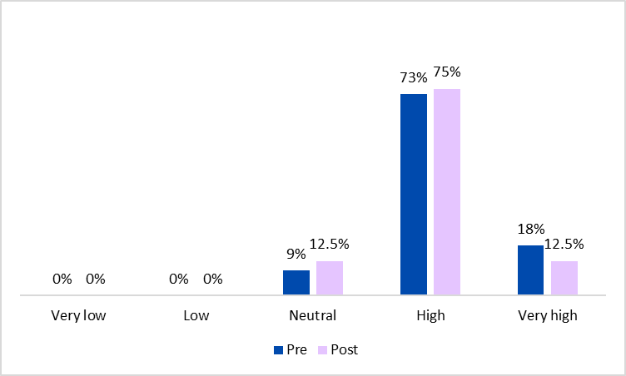
Figure 1. Pre- and post-forum ratings of understanding mental health promotion as a critical health and wellbeing priority area.
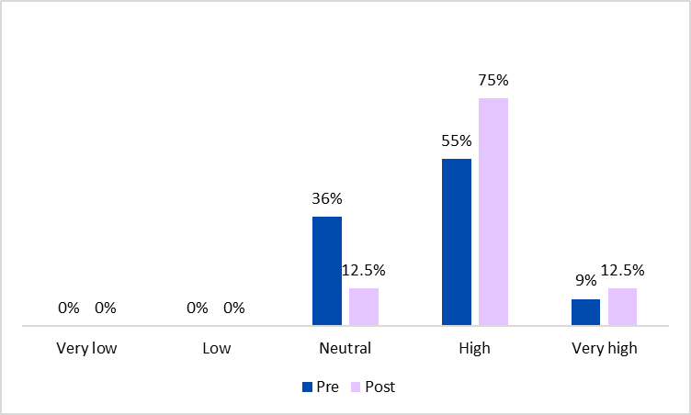
Figure 2. Pre- and post-forum ratings of understanding how the determinants of mental wellbeing extend across all social determinants, and all health priority areas.
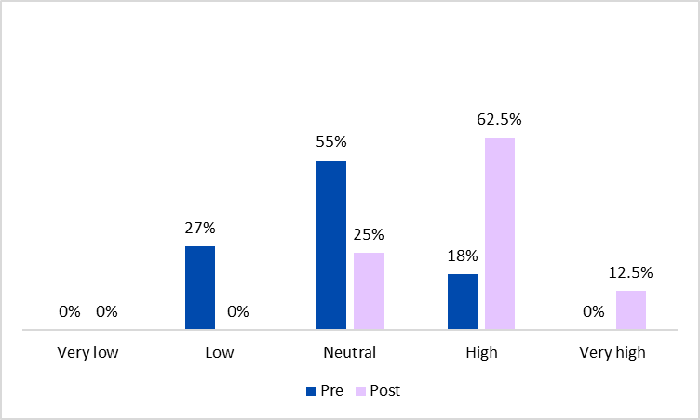
Figure 3. Pre- and post-forum ratings of understanding the local context and needs analysis for gender transformative mental health promotion in the Southern Metropolitan Region.
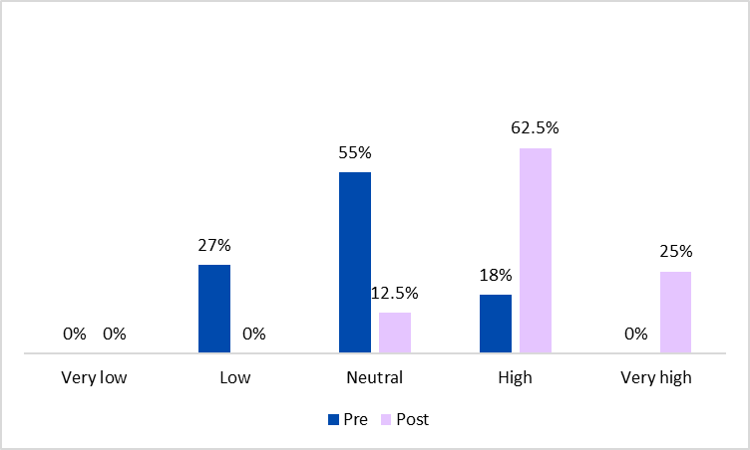
Figure 4. Pre- and post-forum ratings of understanding legislative obligations and requirements for local government to address gender transformative mental health promotion.
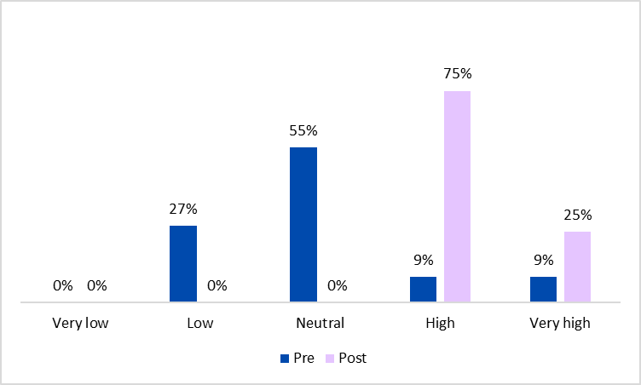
Figure 5. Pre- and post-forum ratings of understanding existing frameworks and policy to enable mental health promotion and activities.
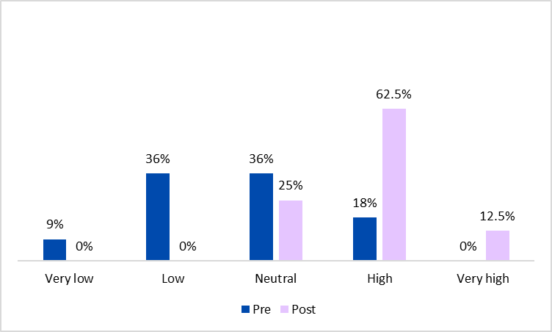
Figure 6. Pre- and post-forum ratings of understanding opportunities and enablers to integrate gender transformative mental health promotion and activities in local government settings.

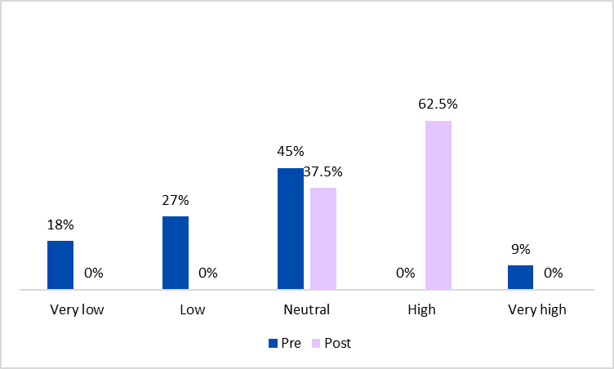
Figure 7. Pre- and post-forum ratings of understanding examples of best practice in municipal gender transformative mental health promotion and activities.

Confidence to apply learnings at work
The surveys also measured changes in confidence to:
- Utilise existing legislation, frameworks and case studies to apply gender transformative mental health promotion and activities within your local government context
- Identify opportunities for gender transformative mental health promotion and activities within your local government context
- Integrate gender transformative mental health promotion and activities within your local government setting
Figures 8 to 10 demonstrate incredible increases in confidence across all measures. Most noteworthy is the overall increase in confidence to identify opportunities for gender transformative mental health promotion and activities within local government contexts (see Figure 9). Before the forum, 45% of respondents felt not at all confident to do this, however, following the forum, 75% felt confident and one person said that they were very confident. Figures 8 and 10 similarly show that about half of attendees felt not at all confident before the forum but following the forum, reported feeling fairly confident or confident.
This is an excellent outcome as confidence can be hard to change as we are asking people to put their learning into action which requires a deeper understanding and application of knowledge.
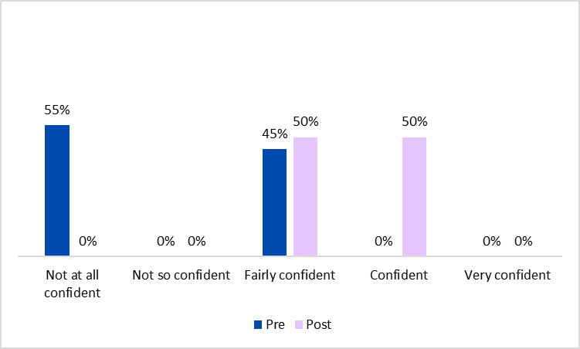
Figure 8. Pre- and post-forum ratings of confidence to utilise existing legislation, frameworks and case studies to apply gender transformative mental health promotion and activities within your local government context.
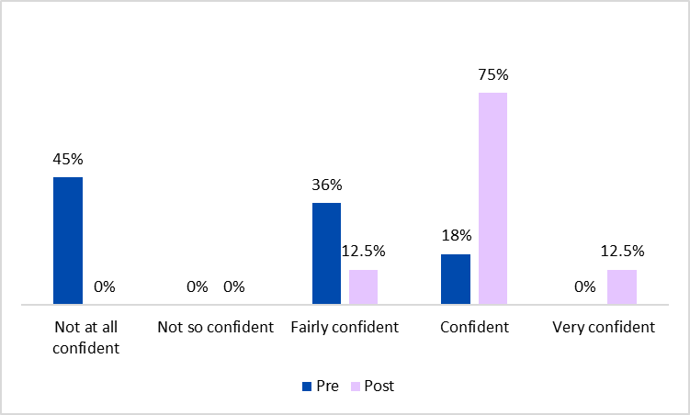
Figure 9. Pre- and post-forum ratings of confidence to identify opportunities for gender transformative mental health promotion and activities within your local government context.

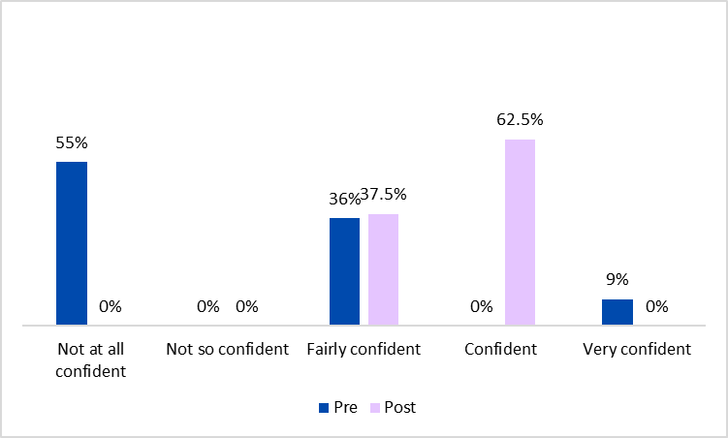
Figure 10. Pre- and post-forum ratings of confidence to integrate gender transformative mental health promotion and activities within your local government setting.

