FRAMEWORK
Embedding Lived Experience in the Primary Prevention of Gender-Based Violence

Contents
Background 3
Acknowledgement 3
Principles for Best Practice 4
What is Primary Prevention? 5
Purpose 6
Theory of Change 6
The Process 7
Step 1: What is the problem you are trying to solve? 8
Step 2: How does the problem contribute to the perpetration of gender-based violence? 9
Step 3: Is your organisation ready to engage lived experience? 11
Step 4: Do you have ongoing support for lived experience practitioners and advocates? 14
Step 5: Do you know how to engage lived experience? 15
Step 6: Are you able to recruit and provide support for lived experience practitioners? 17
Step 7: How will you use co-reflection and evaluation? 18
Conclusion 19
References 19

Background
The Promoting Respect and Equity Together regional prevention of gender-based violence strategy for the Southern Metropolitan Region brings together over 30 organisations. These primary prevention organisations and practitioners work to address the drivers of gender-based violence challenge discrimination and oppression and to identify systemic and structural changes, all of which contribute to the prevention of gender-based violence. It’s important to ensure that this work is both informed by and responds to, the needs of people with lived experience.
This Lived Experience Framework has come about after the Aligning the Personal to the Professional Conference in October 2022, the Embedding Lived Experience Forum in July 2023 and a Lived Experience Framework Think Tank with partners in April 2024. A framework for lived experience aims to be a guide for organisations and practitioners to safely and ethically embed lived experience across a wide range of work to strengthen primary prevention of gender-based violence practice.

Acknowledgement
We want to take this opportunity to thank all the people who have contributed to this framework from across the Promoting Respect and Equity Partnership. This partnership comes together to collaborate on the regional strategy to prevent gender-based violence in the Southern Metropolitan Region. This Framework has developed in partnership them including:
Better Health Network
Bayside Peninsula Integrated Family Violence Partnership
Family Life
Multicultural Centre for Women’s Health
Monash Health
Southern Metropolitan Family Violence Regional Integration Committee
South East Community Links
Wellsprings for Women
Women’s Health in the South East and
Women with Disabilities Victoria

Principles for Best Practice
The following Principals for Best Practice have been adapted from the Experts by Experience Framework.
Recognise that people with lived experience are knowledge holders and have particular expertise about that experience and that their value is reflected in organisational policies and governance structures.
Support lived experience practitioners and advisors with trauma-informed support and appropriate supervision are made available.
Safety of lived experience practitioners, advisors and other staff is given upmost importance by the organisation in terms of legal, physical, emotional and cultural safety.
Trust is built between the lived experience practitioners and the organisation. Power imbalances are addressed by reducing traditional barriers and genuinely involving the lived experience practitioners in decision-making.
Value the lived experience practitioners or advocates by remunerating them fairly for their time, contributions and expenses when they provide input into programs, policies and practice.
Reciprocity will be promoted through a commitment to shared information exchange and learning.
Transparency will ensure lived experience practitioners/advocates have a clarity of purpose and information to make decisions, including their degree of influence, the nature of the engagement and time commitments.
Inclusion will ensure the organisation strives to gain insight from a broad range of perspectives and voices that may not usually be heard.
Accountability will be reflected by regular review, evaluation and accompanied by clear complaints and feedback mechanisms.
Sustainability will be ensured by adequate resourcing to allow for long-term work, for partnerships to be built and key learnings to be shared across the primary prevention sector.

What is Primary Prevention?
“A primary prevention approach [to preventing gender-based violence] works to change the underlying social conditions that produce and drive violence against women, and that excuse, justify or even promote it. It works across the whole population to address the attitudes, norms, practices, structures and power imbalances that drive violence against women.”
The way that the continuum of Primary Prevention, Early Intervention, Response and Recovery are usually depicted are either in pyramid form as per Our Watch or in linear form as per Safe and Equal.
For the purposes of the Lived Experience Framework it is proposed to see the work in a circular model whereby response and recovery can inform prevention and that working in the prevention sector may also support lived experience practitioners or others using their lived experience in their recovery and healing.
Usually the spectrum of work is presented like this:
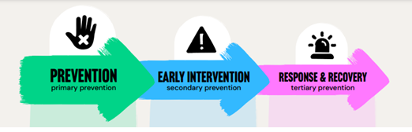
Safe and Equal. 2023
However, prevention (and response) can be seen as interconnected and working at various levels as shown by Safe and Equal below:
Safe and Equal. 2023
If the model is seen in this way, it provides the primary prevention sector with a challenge: that while it is benefiting from the lived experience of the workforce/volunteers/consumer, it also has a responsibility to ensure people with lived experience gain what they need for their recovery journey, whether they are migrant or refugee women suffering from economic marginalisation and racism, or men who use violence who have been victims of childhood trauma or patriarchal norms.

Purpose
To ensure that primary prevention of gender-based violence is both informed by and responds to, the needs of people with lived experience of gender inequality and multiple intersecting forms of oppression and discrimination and/or marginalisation.
To build capacity of organisations who work in primary prevention to value and embed lived experience in the most evidence-based, ethical and best-practice ways.
To build capacity of practitioners to embed lived experience in ways that ensure the work reflects the needs of the communities for whom the work is designed.
To ensure that people with lived experience are valued and respected through ethical, clear and accountable processes.
To ensure that mutuality: opportunities for training, career development, appropriate remuneration and other methods of recognition are built into organisations’ ways of working.
To explore the links between embedding lived experience in primary prevention and the possibility for healing, recovery and empowerment.

Theory of Change

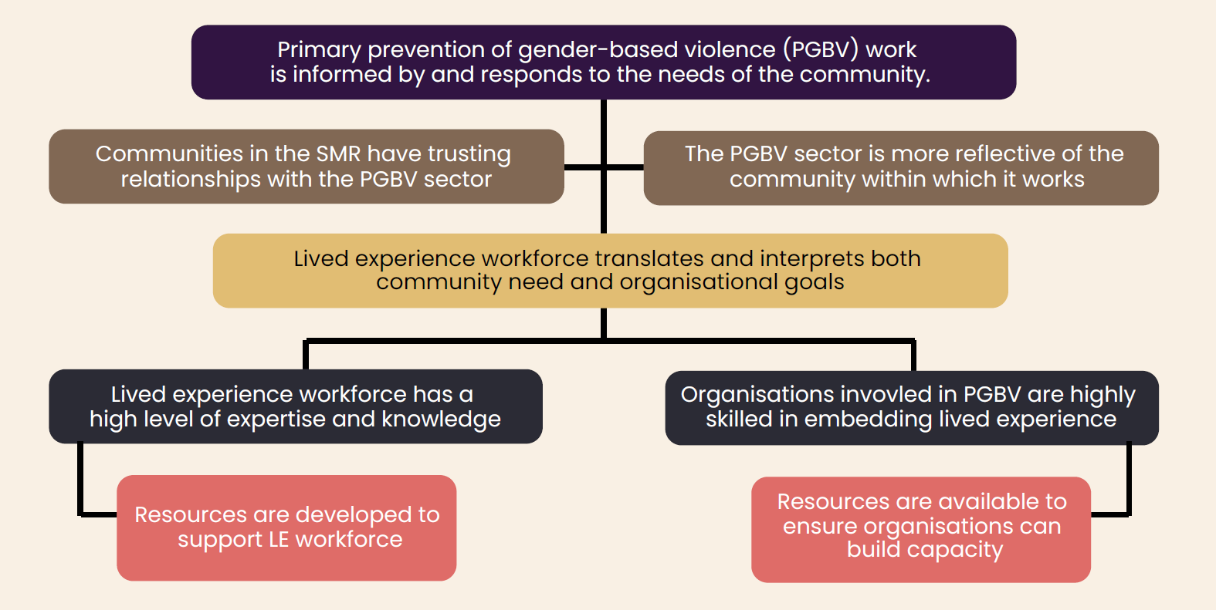
Theory of Change

The Process

This framework will ask you a set of questions: by answering these questions and working your way down the framework; you will begin the process of embedding lived experience. Users will develop an understanding of how to plan to embed lived experience in primary prevention of gendered violence activities.

Step 1: What is the problem you are trying to solve?
Framing issues in primary prevention into problem statements can be particularly challenging due to the strengths based and proactive nature of the work, which needs to focus on preventing problems before they start.
Step 2: How does the problem contribute to the perpetration of gender-based violence?
Linking the subjects, settings, and issues addressed in your primary prevention initiative to the drivers of GBV (gender-based violence), you will create a clear connection between your initiative and the cessation of violence.
Step 3: Is your organisation ready to engage lived experience?
The truth is that primary prevention practitioners and agencies come in all sorts of different shapes and sizes and readiness to engage with lived experience. Organisations need to make sure they can adequately support the needs of practitioners and advisors with lived experience.
Step 4: Do you have ongoing support for lived experience practitioners and advocates?
Ongoing support for lived experience practitioners and advocates is crucial to ensure their wellbeing and effectiveness, providing necessary resources such as a support network, mentoring, professional development, trauma-informed supervision, and recognition.
Step 5: Do you know how to engage lived experience?
Engage lived experience by using the IAP2 engagement spectrum as a tool, which includes consulting for feedback, involving lived experience in defining challenges, collaborating as partners in decision-making, and empowering lived experience to make final decisions.
Step 6: Are you able to recruit and provide support for lived experience practitioners?
Recruit and establish the right supports for your work including implementing any policies and practice that will remunerate the lived experience for their time and efforts.
Step 7: How will you use co-reflection and evaluation?
As with all primary prevention work, evaluating and reflecting on the value and impact of our work is vital – to both contribute to the evidence of our practice, and, to learn and improve our work for the future. When we work with lived experience, involving those with lived experience is crucial to this stage.

Step 1: What is the problem you are trying to solve?
Framing projects as a problem can enhance our understanding of issues by:
- Clarifying: What is currently happening and what the desired state should be.
- Focusing: Focus attention on specific aspects that need improvement.
- Being solution-oriented: explore different ways to overcome the challenge.
- Measuring and Analysing: Setting clear metrics for success, helps to track progress and evaluate.
- Collaboration: A well-defined problem can galvanize a team or community, fostering collaboration as people unite with a common purpose.
- Learning and Adaptation: Ensures iteration, flexibility, learning and continual improvement.
Framing issues in primary prevention into problem statements can be particularly challenging due to the strengths based and proactive nature of the work, which needs to focus on preventing problems before they start. Here are some tips on how to effectively frame these issues into clear problem statements:
- Identify the root cause: Begin by understanding the underlying factors that contribute to the potential problem. This involves researching and gathering data on why certain issues might arise.
Our Watch, Change the Story Framework
- Define specific objectives: Clearly define what you aim to achieve with the prevention strategy. This specificity will guide the problem statement to focus on actionable outcomes.
Instead of "reduce violence," say "reduce the adherence to rigid gender stereotypes by men aged 12-25 in the Southern Metropolitan Region."
- Understand the population: Know the characteristics of the population that is at risk of using violence or being a victim/survivor.
- Set clear, measurable goals: Make sure the goals included in the problem statement are measurable.
- Highlight the benefits: Include the potential benefits of addressing the problem in the statement.
For primary prevention of gender-based violence, we can say that by embedding lived experience we ensure that the population groups with whom we work are given an opportunity to heal, recover and be empowered through participation in our initiatives.
- Use simple, direct language: Since the goal is to motivate action, the problem statement should be concise, clear, and easily understandable.
- Include a call to action: invite stakeholders to participate in the solution through a specific action. This should inspire collective effort and commitment towards achieving the prevention goals.
By framing problem statements in this way, you can effectively set the stage for proactive measures in primary prevention, ensuring that efforts are directed towards meaningful, measurable outcomes.

Step 2: How does the problem contribute to the perpetration of gender-based violence?
This framework focuses on embedding the lived experiences of various forms of discrimination and oppression into our efforts to prevent gender-based violence. Linking the subjects, settings, and issues addressed in your primary prevention initiative to the drivers of GBV (gender-based violence), you will create a clear connection between your initiative and the cessation of violence. This is also the opportunity to discuss the evidence supporting primary prevention and the underlying factors driving GBV. Additionally, this is an ideal moment to delve into specific evidence and data relevant to the problem at hand, whether it relates to a particular setting, region, or local area.
What is the lived experience at the heart of this matter?
At this point in the planning process practitioners/organisations need to consider the type(s) of lived experience to involve. This will be based on the context of the ‘problem’ or issue and should seek to understand the privilege and power that you hold, and the consequence of this on your understanding of the problem.
Ask yourself, what do you not know.
This is the point where you start to learn about what kind of lived experience in this project, initiative or strategy you need to centre.
Defining lived experience for primary prevention
Lived experience in the context of the primary prevention of gender-based violence refers to the ‘direct, or indirect (as in affected other’s or affected family members) experience, past or present, of a social issue and/or injustice’, and this experience of oppression and/or discrimination informs the primary prevention sector’s work if integrated in a culturally appropriate and safe manner, embodying the principle of ‘nothing about us, without us’. A lived experience practitioner is someone who can contextualise experiences mentioned above and apply that knowledge to the benefit of others.
Within an organisation there can be different roles for lived experience workers, such as:
- Lived experience practitioner
An umbrella term for a community member who is employed because of the learning from their lived experience of intersecting discrimination and/or oppression, and their ability to apply this to work practice, and this is explicitly specified as criteria of the role.
- Lived experience advocates/advisors
People with lived experience who sit in an advisory capacity to support organisations doing primary prevention and who can contribute their expertise in an advisory capacity. This could include on Boards or Governance structures, supporting grant applications or inquiry submissions. These positions would need to be remunerated.
- Lived experience workforce
Lived experience practitioners who are employed in roles that require them to identify as having had lived experience of a particular intersection of discrimination or oppression. Lived experience identified in the criterion of their position descriptions, although job related tasks may vary.
- Primary prevention practitioners
Primary practitioners who don’t have the requirement of disclosing lived experience, and it’s not a requirement in their position descriptions. These practitioners may or may not have lived experience of discrimination or oppression.
This highlights the importance of developing very specific workplace policies, procedures, recruitment practices and roles with lived experience position descriptions with clear expectations, additional support for lived experience practitioners’ mental health and wellbeing. The organisation also should undertake organisational readiness training to ensure that existing staff and management understand the purpose of these new roles and to ensure the practitioners or advocates are valued for their expertise.

Step 3: Is your organisation ready to engage lived experience?
The truth is that primary prevention practitioners and agencies come in all sorts of different shapes and sizes and readiness to engage with lived experience.
Organisations need to make sure they can adequately support the needs of practitioners and advisors with lived experience. They need to ensure:
- An awareness of, and commitment to the value lived experience, and integrate into their work and program design. Organisations that do this include insights from lived experience into their programs/activities from diverse perspectives.
- Resources are expended to build capacity of staff to gather, understand and use lived experience in their work.
- The organisation has tangible evidence of cultural competence where diverse experiences and perspectives are respected and valued.
- There must be a supportive infrastructure in place that is there for enabling the organisation, its work and projects to not only hear the voices of lived experience, but also listen and integrate those perspectives. Feedback mechanisms are also a part of this. For instance, committees, specific roles, budget allocation, professional development
- The organisation has policies in place, and a governance structure that describes the value of incorporating lived and also how lived experience will be built into the work and decision-making processes of the organisation
- There is deliberate evaluation and learning from the process and the work to integrate lived experience and evolve the practice and policies of the organisation.
Some questions to answer for organisations have been outlined by Drummond Street Services and the Centre for Family Research and Evaluation and have been adapted for the purposes of the Primary Prevention sector.
Organisational Readiness Checklist
- Values of the service and its staff:
Initiatives are more likely to be successfully implemented if they fit with the core values of the organisations and staff.
- How does lived experience knowledge fit with your service’s values, mission and strategic objectives?
- How will you engage your existing staff around their values and beliefs in relation to lived experience?
- How do you recognise and address power imbalances and engage in power-sharing?
- Organisational policies and systems:
To be embedded sustainably within an organisation, the new program needs to be reflected in core organisational systems and processes.
- Does the organisation have lived experience policies and procedures, and are they effectively implemented?
- Do other relevant policies (e.g., recruitment) need to be updated to reflect the inclusion of lived experience workforce?
- Does the organisation have diversity, inclusion and/or intersectionality policies and procedures?
- Does the organisation have clear processes in place for how their lived experience workforce will work alongside other staff and programs?
- Have supervision processes been adapted to suit the unique needs and experiences of a lived experience workers?
- Training and Capacity Building
Training and capacity building is an opportunity to upskill and support existing and new staff so that practice is collaborative and effective.
- Has the service resourced trainings to understand the role of lived experience of multiple, intersecting forms of oppression and discrimination in the service?
- Has the service resourced training to understand the roles, purpose, and integration of lived experience workers.
- Have staff had opportunities to work collaboratively to co-develop and knowledge share with lived experience workers?
- Will supervisors receive training and support in supervising a lived experience workforce?
- How will lived experience workers receive training and support in their ongoing professional development (including to address Mandatory Minimum Qualifications)?
- Leadership
Leadership occurs across all levels of a service but requires genuine awareness of who holds power and influence to create change.
- Will service leaders at all levels be involved in implementing the program?
- Do leaders provide an authorising environment (e.g., setting a positive, constructive tone and promoting the value of incorporating lived experience workers)?
- Do leaders appropriately use their power to challenge barriers to change, including by engaging in power-sharing with stakeholders.
- Stakeholder engagement
Involving and centring the voices of stakeholders with lived experience of multiple, intersecting forms of oppression and discrimination is critical to addressing the key needs.
- Have staff with lived experience of multiple, intersecting forms of oppression and discrimination been consulted and invited to contribute their expertise?
- Have all staff been briefed about the purpose of, and their role in, building a lived experience workforce?
- Have relevant community groups, people with lived experience and/or clients been engaged as stakeholders or as part of an advisory group?
- How is power shared so that involvement of stakeholders is genuine and effective, rather than tokenistic?
- Review and support
Keeping implementation on the agenda and staff engagement high is key to the success of supporting your intersectional lived experience workforce.
- Do you have a plan for evaluating and reviewing program outcomes?
- Have you established a lived experience working group that will meet regularly, and include representatives at all levels of the organisations?
- Have regular forums and processes for all staff to provide feedback and raise concerns or positive experiences of the program been established?
- Is there a process in place for regular consultation and feedback with the lived experience workforce?
This is the point where you start to reach out through your networks, to discover, engage and learn from lived experienced to ensure that your primary prevention initiative is doing what it needs to do. Your organisation may have many strengths and ready for engagement, or perhaps not, depending upon where you are, there are a range of ways that you can maximise readiness to centre lived experience in your primary prevention work.
Do your executives and leaders have lived experience training?
Do your leaders:
- Understand lived experience and how to embed it within an organisation?
- Understand how lived experience furthers the goals of the organisation?
- Recognise the value of building a diverse lived experience workforce?
- Have the capacity to implement a lived experience workforce development initiative?
- Understand how to identify personal biases and barriers to embracing lived experience?
- Know how they will create an authorising environment for the initiative including within the policies and structures of the organisation?

Do your current staff and practitioners have training in how to support lived experience?
Do your current staff:
- Understanding of lived experience, specific roles, where it sits organisationally and its alignment with the mission, values and philosophy of the organisation.
- Understanding of when to and when not to involve lived experience, the ethics and the cultural nuances of the initiative.
- Have the cultural competency capacity to work in a safe and ethical way with lived experience workforce.
- Recognise barriers and biases to embedding lived experience and develop authentic power-sharing mechanisms that can be tested and measured.
- Have capabilities such as:
  - Active listening
  - Reflective practice
  - Power-sharing and co-design techniques
  - Self-care strategies

Training for lived experience practitioners or advocates
Do your lived experience workforce:
- Understand their own readiness for being lived experience practitioner?
- Know how to identify personal strengths, skills and experience but also biases, assumptions and stereotypes?
- Know how to develop a clear lived experience identity and role for the new workforce as well as a strong sense of the unique value they bring to the work?
- Have confidence to use their lived experience to support the work within the organisation?
- Have capabilities such as:
  - Active listening
  - Reflective practice
  - Power-sharing and co-design techniques
  - Self-care strategies
- Have a strong understanding of how to access external support and supervision?

Step 4: Do you have ongoing support for lived experience practitioners and advocates?
Ongoing internal and external support could look like a:
- Lived Experience Support Network for practitioners to come together to learn from each other and support each other with common issues.
- Mentoring opportunities internally or externally to support their professional development
- Support for continued professional development and training to support the work they’re doing within the organisation.
Ongoing external supervision for lived experience practitioners and advocates
- Organisations to provide access to external, trauma informed supervision with an understanding of the challenges that lived experience practitioners would be facing.
- This would be in addition to regular Employee Assistance Programs (EAP).
Other organisational support strategies for embedding lived experience
- A clear evaluation framework to ensure everyone can monitor progress towards their goals.
- Reflective practice mechanisms
- Trust building activities within diverse teams
- Reward and recognition of lived experience workforce and current staff to highlight their value to the organisation.
- Frequent Leadership involvement in the initiative as well as ensuring adequate resourcing both in terms of workforce numbers, training and development and time to devote to activities such as reflective practice, supervision and counselling.
- Specific resourcing for and budget to support lived experience-led projects in community in line with the organisation’s strategic and annual action plans.
By ensuring that your problem is clear, the lived experience that needs to be centred for this primary prevention work will be clear, being aware of the readiness of your organisation/agency and addressing any immediate capability opportunities, you are then ready to engage and work with the lived experience.

Step 5: Do you know how to engage lived experience?
There are a range of ways that you can partner with lived experience to address the problem/challenge you have identified.
Using the IAP2 engagement spectrum as a tool, you can:
- Consult – obtaining feedback from lived experience on analysing alternative approaches and/or decisions
- Involve - working directly with lived experience to process and ensure that the problem/challenge is rightly defined and centre the aspirations, needs and concerns of lived experience
- Collaborate – lived experience stakeholders are partners of the work through each stage of decision making. Lived experience drive the identification of alternatives and solutions
- Empower – the final decision of outcomes is placed in the hands of lived experience.
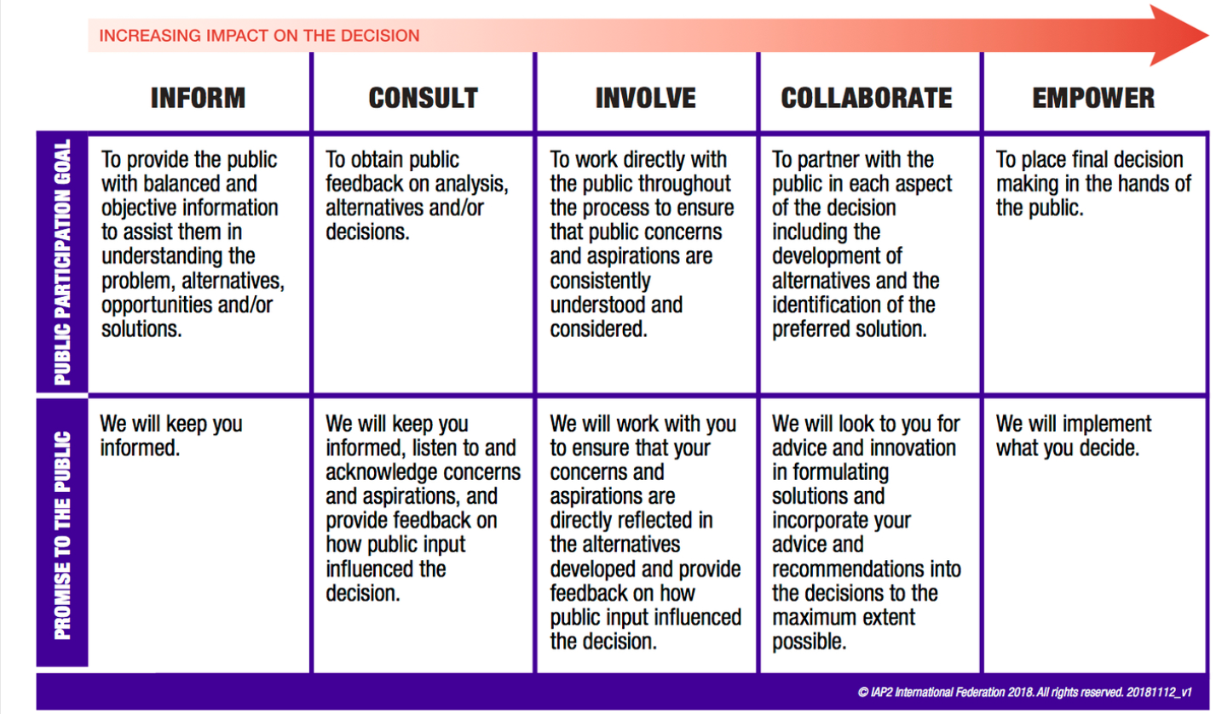
IAP2 Engagement Spectrum
The Family Violence ‘Experts by Experience Framework’ Appendix 2A: Models of Engagement outline the ways “in which survivor advocates of family violence can be engaged to influence policy development, service planning and practice.” For the Primary Prevention sector however, the ways in which lived experience could be engaged would look different. They have been adapted in the table below.
Role | Degree of Influence | Remuneration | Principle Alignment
People with lived experience appointed to distinct lived experience roles within the organisation. | High | Standard hourly rate | This will be embedded in the organisations’ strategic plan, highlighting the knowledge and expertise of people with lived experience and the value they bring to the organisation. Their role will have a clear position description, highlighting their role and the value it brings to the organisation. There will be more than one lived experience role at any one time and will come with additional support and professional development.
Appoint people with lived experience to a nominated number of Board positions. | High | Fee per meeting up to $225* | Ensure that the strategic plan, policies and procedures to embed a certain number lived experience positions on the Board, with full training for them and the existing board on their respective duties. Careful consideration is given to how to reduce power imbalances between lived experience members and other members of the group (such as ensuring there is more than one lived experience representative at any one time).
Engage people with lived experience as paid consultants in strategic planning, in submissions and to write policies. | High | Standard hourly rate | Lived experience consultants will be provided with the emotional support and opportunities they need to prepare for and perform their role and understand their legal responsibilities. Lived experience consultants who are engaged in strategic planning processes will have genuine influence and opportunities to influence decision making.
Nominate people with lived experience to participate in advisory or working groups for an honorarium | Medium | $60 per hour fee per meeting up to $255 | Lived experience Advisors who are engaged in advisory and working groups will have genuine influence and opportunities to influence decision making. They will also be involved in regular reviews and evaluations of their experience being engaged in the advisory or working group
Engage people with lived experience in project work (co-design and co-facilitation) for an honorarium | Medium | $60 per hour fee per meeting up to $255 | Lived experience Project workers will be provided with clarity around their role in the projects. They will also be provided with the emotional support and opportunities to develop the key skills needed to perform their role
Media Advocates paid a fee for their time. | Medium | $240* | Lived experience advocates who express interest will be provided with clarity about how they will be remunerated, tenure, time commitments and scope of their involvement with the ability to withdraw at any time. Considerations relating to the legal, physical, emotional and cultural safety of victim survivors are carefully considered and survivor-led, with guidance available via the self-reflection questions (see below).
Formal and Informal Feedback from people with lived experience remunerated depending on length and type of feedback. | Low | $60 per hour or part thereof* | Communities with whom we work will be involved in designing feedback questions and surveys and will receive feedback about the issues raised and how this feedback has influenced practice.
*Can be paid as an invoice or vouchers (if preferred)

Step 6: Are you able to recruit and provide support for lived experience practitioners?
As per the engagement method and needs identified you can then recruit and establish the right supports for your work including implementing any policies and practice that will remunerate the lived experience for their time and efforts.
Lived Experience Practitioner Readiness
This series of questions has been adapted from Domestic Violence Victoria’s Expert by Experience Framework to support family violence victim survivors decide whether they would like to be formally engaged as a survivor advocate. These questions might provide useful guidance for discussions between an organisation and a survivor during the recruitment process. A checklist to determine organisational readiness is also available.
- Are you ready to undertake the work?
- What are my reasons for wanting to participate as a lived experience practitioner?
- Do I really want to participate or am I feeling that I should?
- Am I ready to disclose my own lived experiences, if necessary?
- What resources do I need?
- Do I have resources in place both personally and professionally to do the work required as a lived experience practitioner?
- What support will I need to ensure my health and wellbeing is not negatively impacted by participation?
- How will I manage the emotions associated with working in projects touching on my lived experience?
- What strategies will I use if someone reacts negatively or judgmentally to my expertise?
- How do I make sure I am safe?
- Is it safe for me to participate?
- re there any ongoing risks posed by any past or current lived experience of oppression and/or discrimination?
- Where am I in terms of my recovery and healing journey?
- Are there protections that can be put in place to increase my safety?
- Do I know if this organisation has procedures in place to record and remember the safety protections I want to put in place?
- How can I establish my boundaries?
- How will I ensure my personal and professional boundaries are upheld?
- What are my personal limits regarding what I am happy to contribute as a lived experience practitioner?
- Am I able to contextualise my own experiences to help others or is it all too fresh in my memory?
- Am I clear about the limitations of this role and who I can represent when I speak publicly?
- Am I clear about what other practitioners bring to the work and how lived experience can complement their expertise?

Step 7: How will you use co-reflection and evaluation?
As with all primary prevention work, evaluating and reflecting on the value and impact of our work is vital – to both contribute to the evidence of our practice, and, to learn and improve our work for the future. When we work with lived experience, involving those with lived experience is crucial to this stage.
While it is the practice of primary prevention and health promotion professionals to develop program logic/theory of change models to ensure that the work is delivering outcomes, there are ways that we can evolve this technique to include lived experience:
- Include lived experience workers/advocates in the development of theory of change/logic work to strengthen the framework and pathway so that the pathway of activities is more strongly aligned to outcomes, and that the outcomes and impacts identified are what is required by our communities
- Ask lived experience workers/advocates to provide their input at the point of evaluation to provide evidence and feedback on the value of lived experience in the activity/program/strategy and also, if the organisation has delivered a supportive experience for lived experience workers/advocates through the process, and how this can be improved

In addition, lived experience workers/advocates can contribute to the evaluation the following ways:
- Participatory evaluation: Lived experience workers/advocates can be involved in the design, implementation, and analysis of evaluation processes. This allows them to provide valuable insights based on their lived experiences and perspectives, ensuring that the evaluation is culturally relevant, sensitive, and addresses the real needs and concerns of the target community.
- Qualitative data collection: Lived experience workers/advocates can play a crucial role in conducting qualitative data collection methods, such as focus group discussions, in-depth interviews, and community consultations. Their shared experiences and rapport with the target community can facilitate open and honest dialogue, providing rich insights into the perceptions, attitudes, and experiences of the community members regarding the prevention activities.
- Interpretation and analysis of findings: Lived experience workers/advocates can contribute to the interpretation and analysis of evaluation findings. Their unique perspectives can help contextualize the data, identify nuances, and provide valuable insights into the underlying reasons behind certain findings, which might not be apparent to external evaluators.
- Advisory and consultative roles: Lived experience workers/advocates can be engaged as advisors or consultants throughout the evaluation process. Their involvement can ensure that the evaluation design, tools, and processes are culturally appropriate, relevant, and sensitive to the needs and experiences of the target community.
- Dissemination and reporting: Lived experience workers/advocates can play a role in disseminating and reporting the evaluation findings to the community and other stakeholders. Their involvement can enhance the credibility and acceptance of the findings, as well as facilitate the translation of the evaluation results into actionable recommendations and strategies.
- Capacity building: Lived experience workers/advocates can be involved in capacity-building efforts related to evaluation. This can include training on evaluation methods, data collection techniques, and analysis, which can empower them to contribute more effectively to future evaluation processes.

Conclusion
We hope that through using this framework, organisations in the Southern Metropolitan region who are involved in primary prevention of gender-based violence will be able to more closely reflect the needs of the communities with whom they work. We hope that these organisations will be able to empower these communities through building their capacity to advocate for themselves, to develop new skills and knowledge in the community sector and to continue to use this guide in an iterative process of learning and development.

References
The Family Violence Experts by Experience Framework: Research Report and Framework 2020. University of Melbourne and Domestic Violence Victoria.
Workforce initiatives: lived and living experience workforces (LLEWs) 2023. The Victorian Department of Health
Australian Framework for the ethical co-production of research with victim survivors 2023. The Centre of Research Excellence, Safer Families, and The University of Melbourne.
Sources of Lived Experience in the Family Violence Sector 2022. Safe and Equal
Intentional Peer Support. SHARC
Iap2 Spectrum of Public Participation. 2018 International Association for Public Participation.
Lived and Living Experience Workforce (LLEW) team. VMIAC
Our Future Project Partnership (2021). Our Future: Developing Introductory Training for the Lived and Living Experience Workforces in Victoria. Self Help Addiction Resource Centre (SHARC)
Consumer Perspective Supervision: A framework for supporting the consumer workforce. 2018. VMIAC, the Centre for Psychiatric Nursing and the University of Melbourne.
NGO Mental Health Lived Experience Workforce Standards and Guidelines: Self-Assessment Tool for Organisations. 2018 Lived Experience Workforce Program (LEWP) MHCSA
Intentional Peer Support (US)
Lived and Living Experience Strategy 2021-2026. cohealth
Centring Lived Experience: A strategic approach for leaders. 2023. Charlotte Lamb, Daniel Seifu and Naomi Chapman.
Lived Experience Leadership: Rebooting the DNA of Leadership. 2019. Baljeet Sandhu

The University of Melbourne. The Family Violence Experts by Experience Framework. Research Report and Framework. 2020. Pg. 19
Our Watch, Change the Story: a shared national framework for preventing violence against women and children (second edition). 2021
Byrne, L., Wang, L., Roennfeldt, H., Chapman, M., Darwin, L. Queensland Framework for the Development of the Mental Health Lived Experience Workforce. 2019, Queensland Government: Brisbane pg. 10.
Cultural, Lived Experience and Identity Knowledge (CLIK) Guide: Resource Kit.
IAP2 International Federation 2018.
Southern Metropolitan Family Violence Regional Integration Committee Remuneration Rates 2024, As guided by Safe & Equal (formally DVVIC) Experts by Experience Framework

